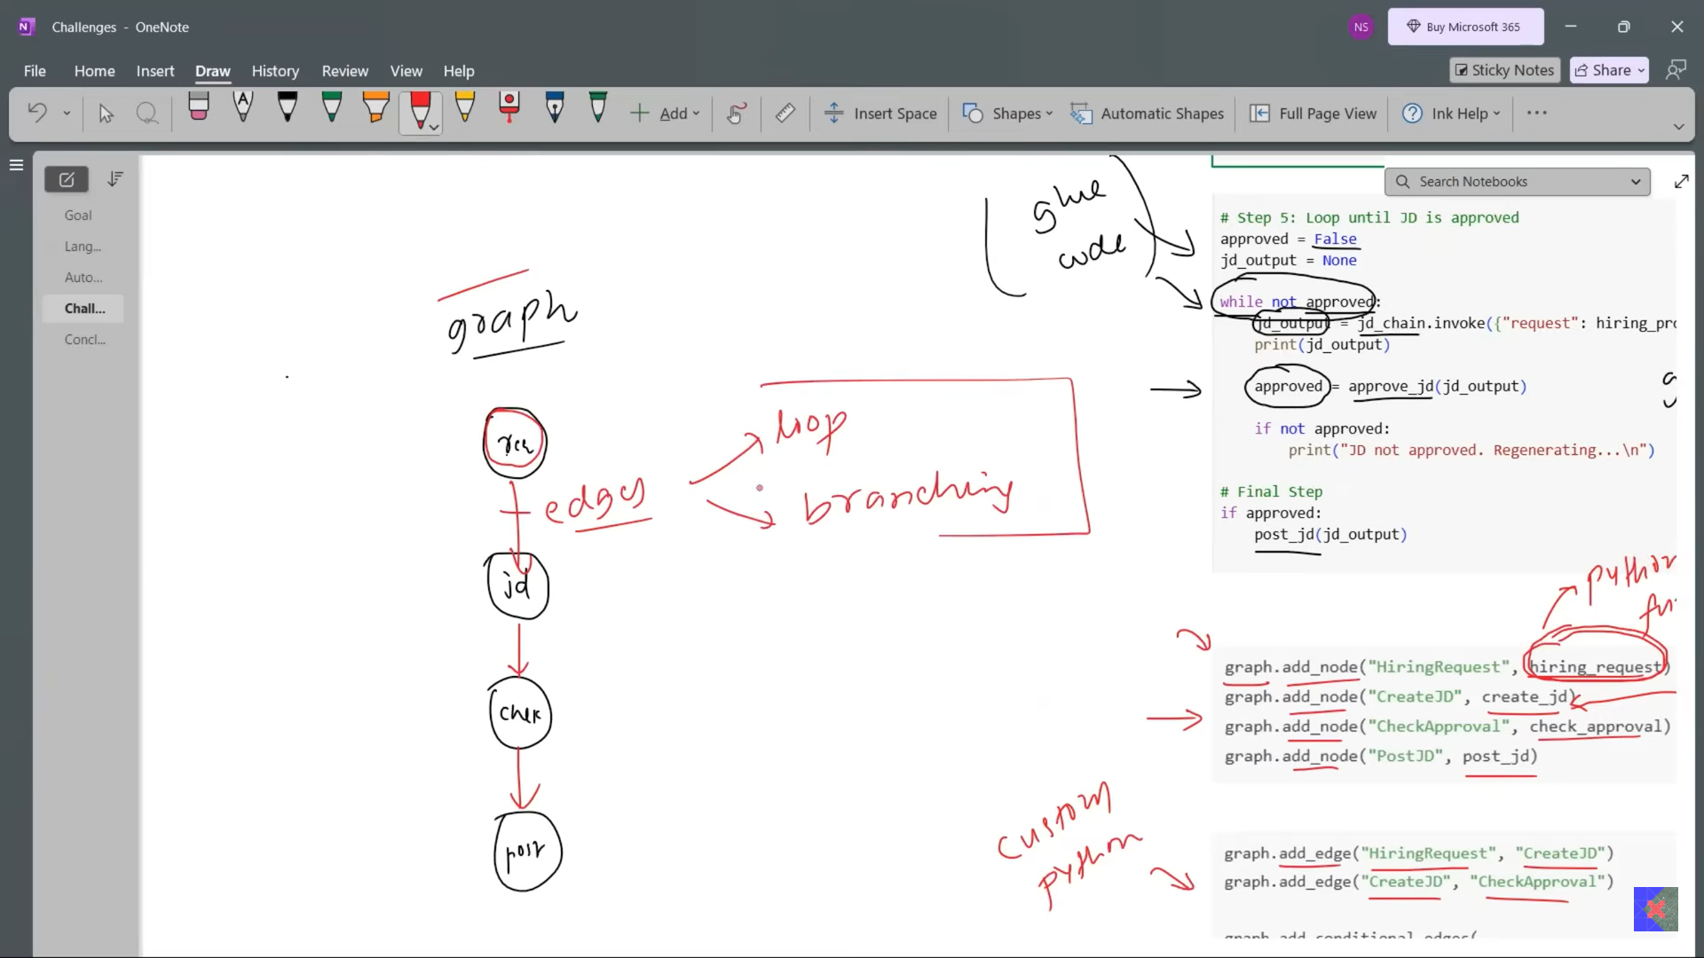

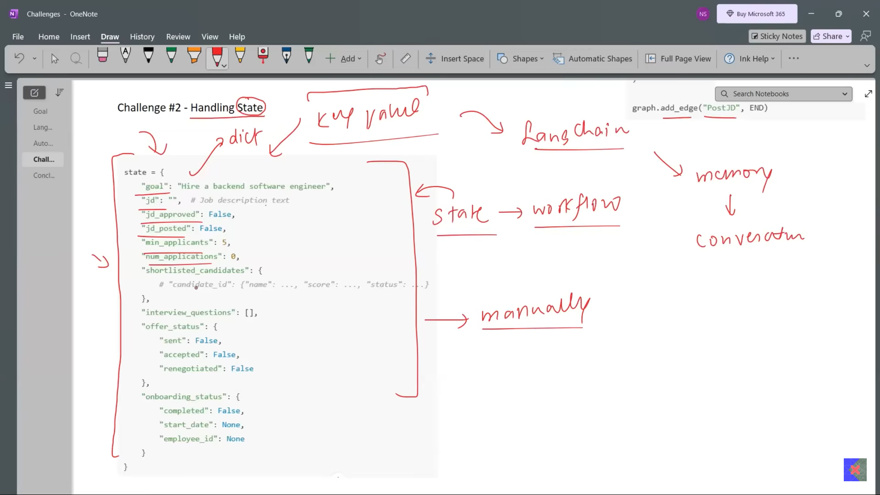

LangChain have not state while langgraph has.

Langchain me bhi ek state dictionary bana sakte hai lekin usko maintain karne muskil ho jaayega.

LangGraph is stateful using TypedDict or Pydantic. Each node have access to this state.

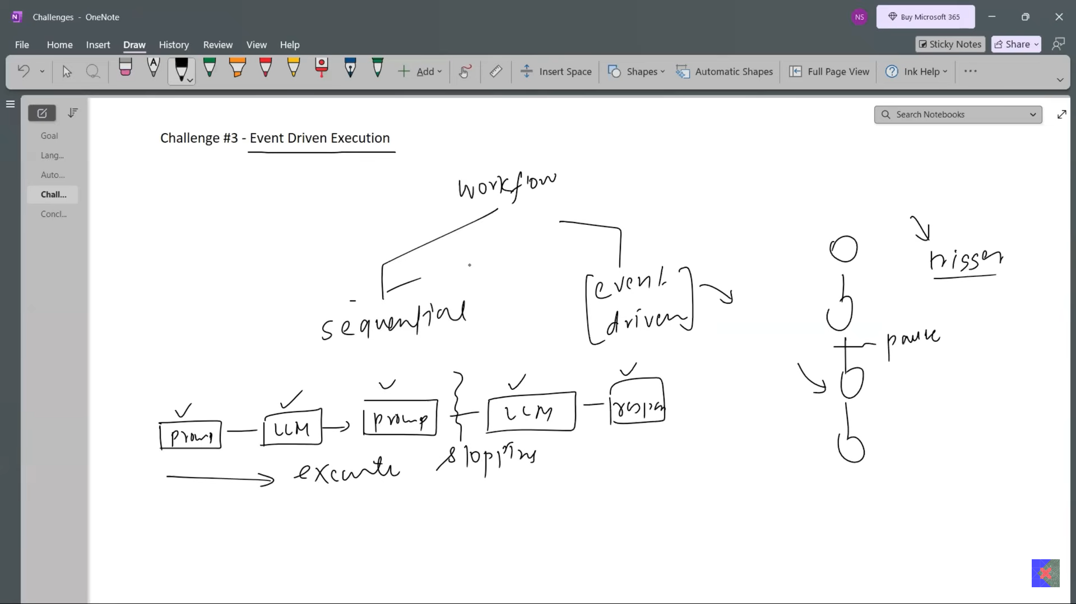

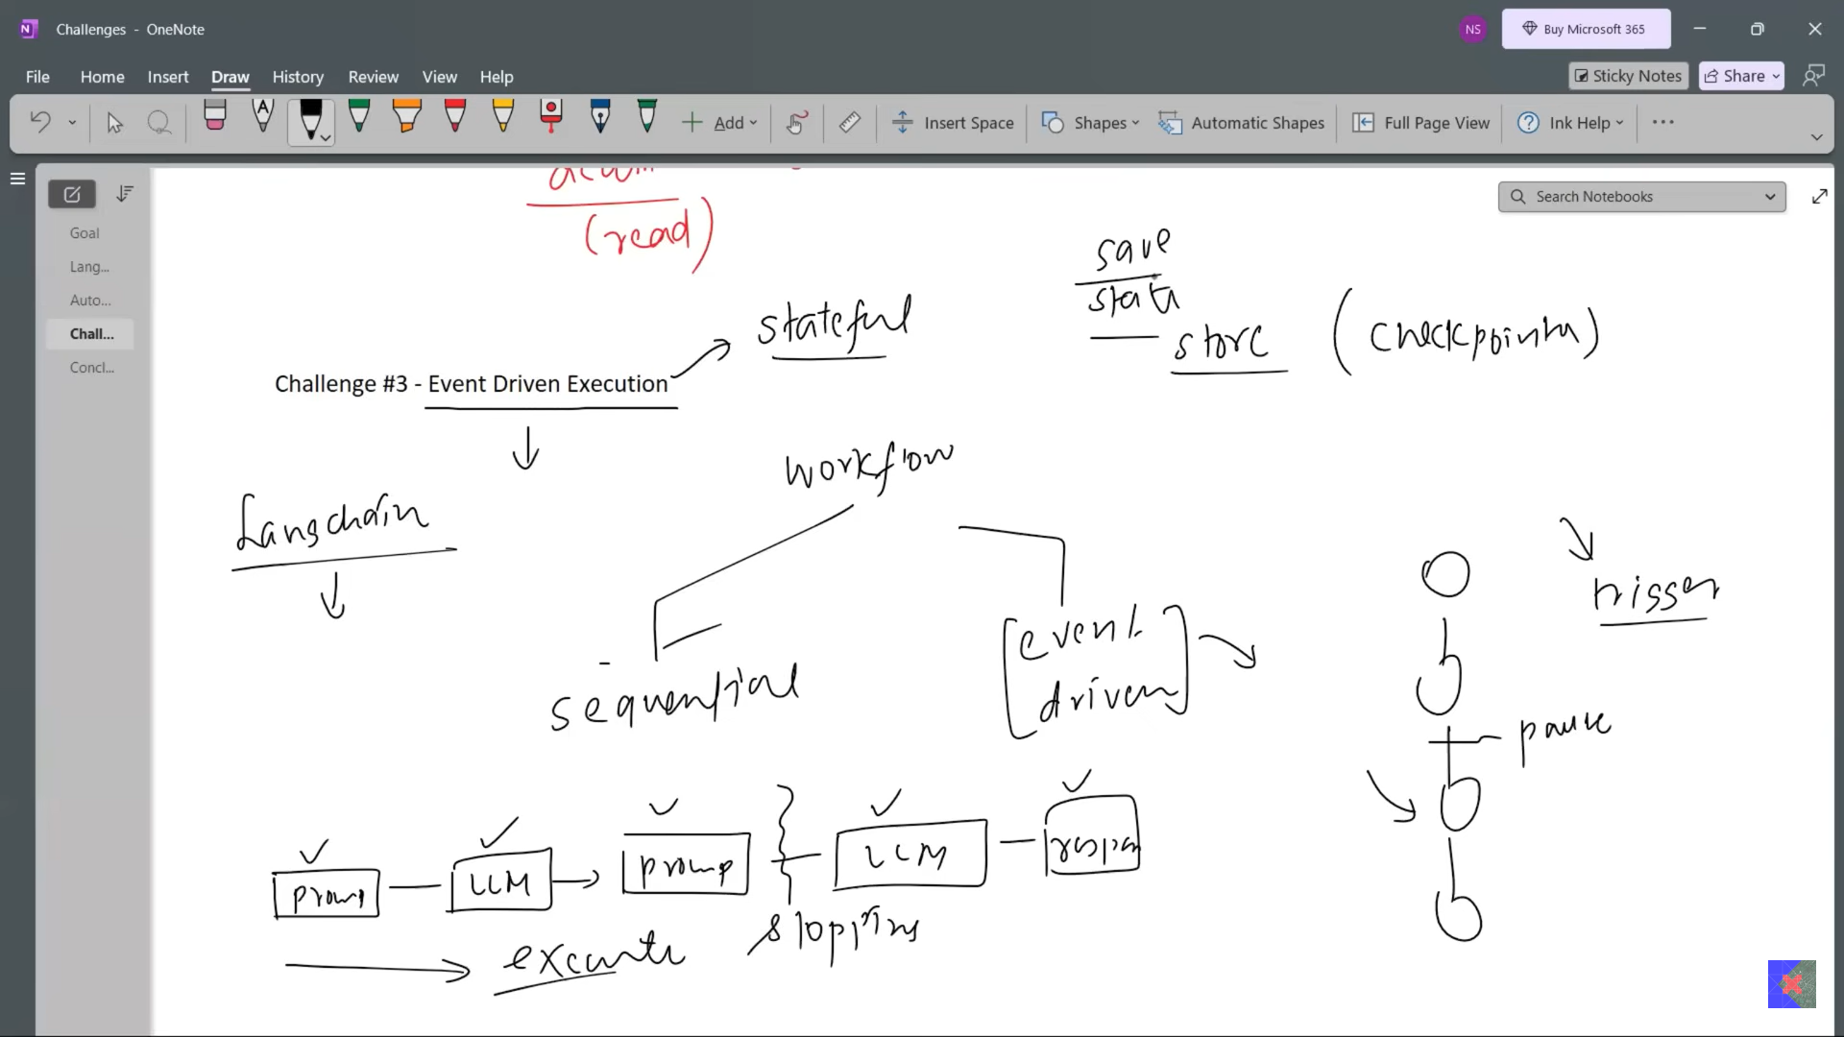

LangGraph me state driven workflow implement karna aasan hai.

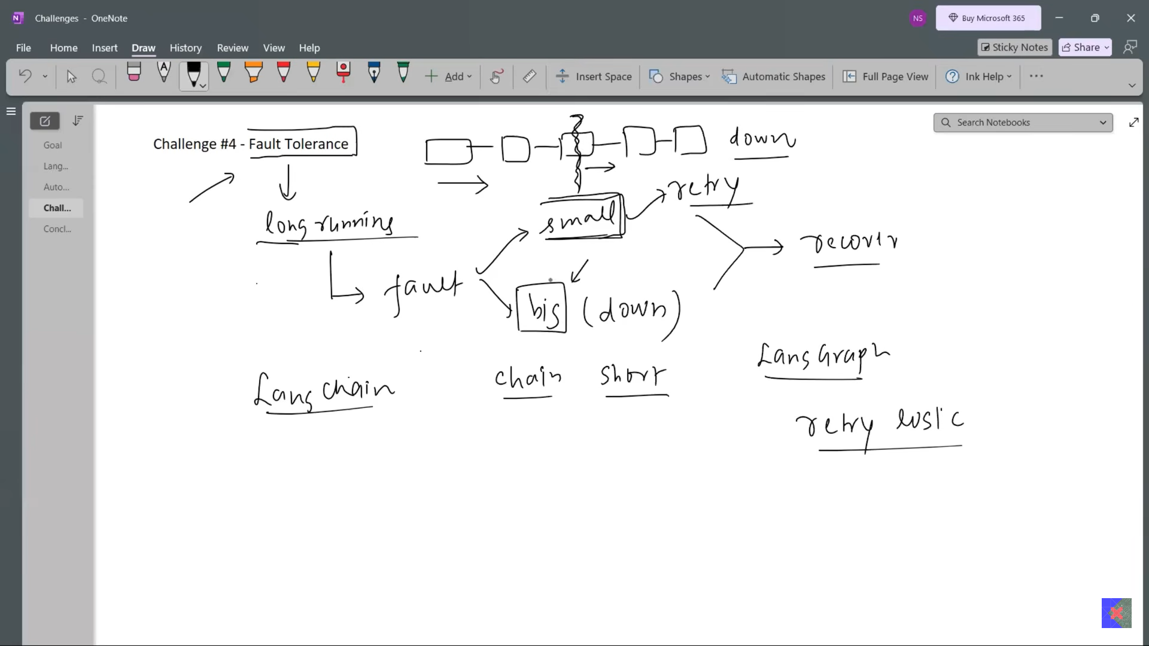

LangChain has not recovery option while LangGraph has.

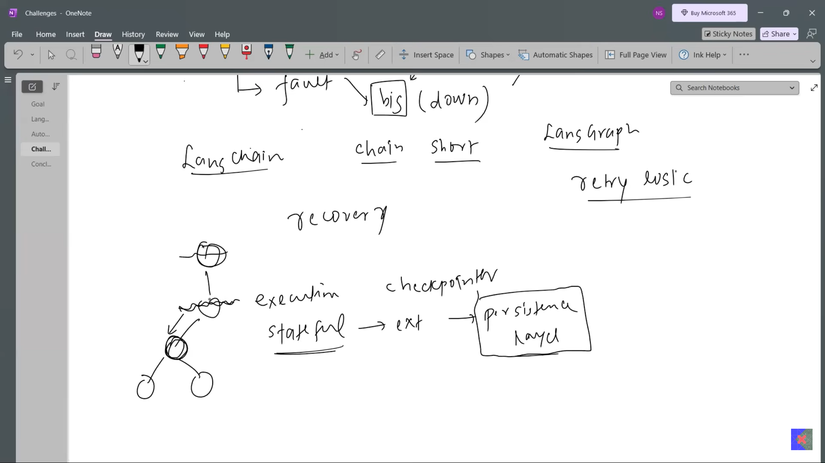

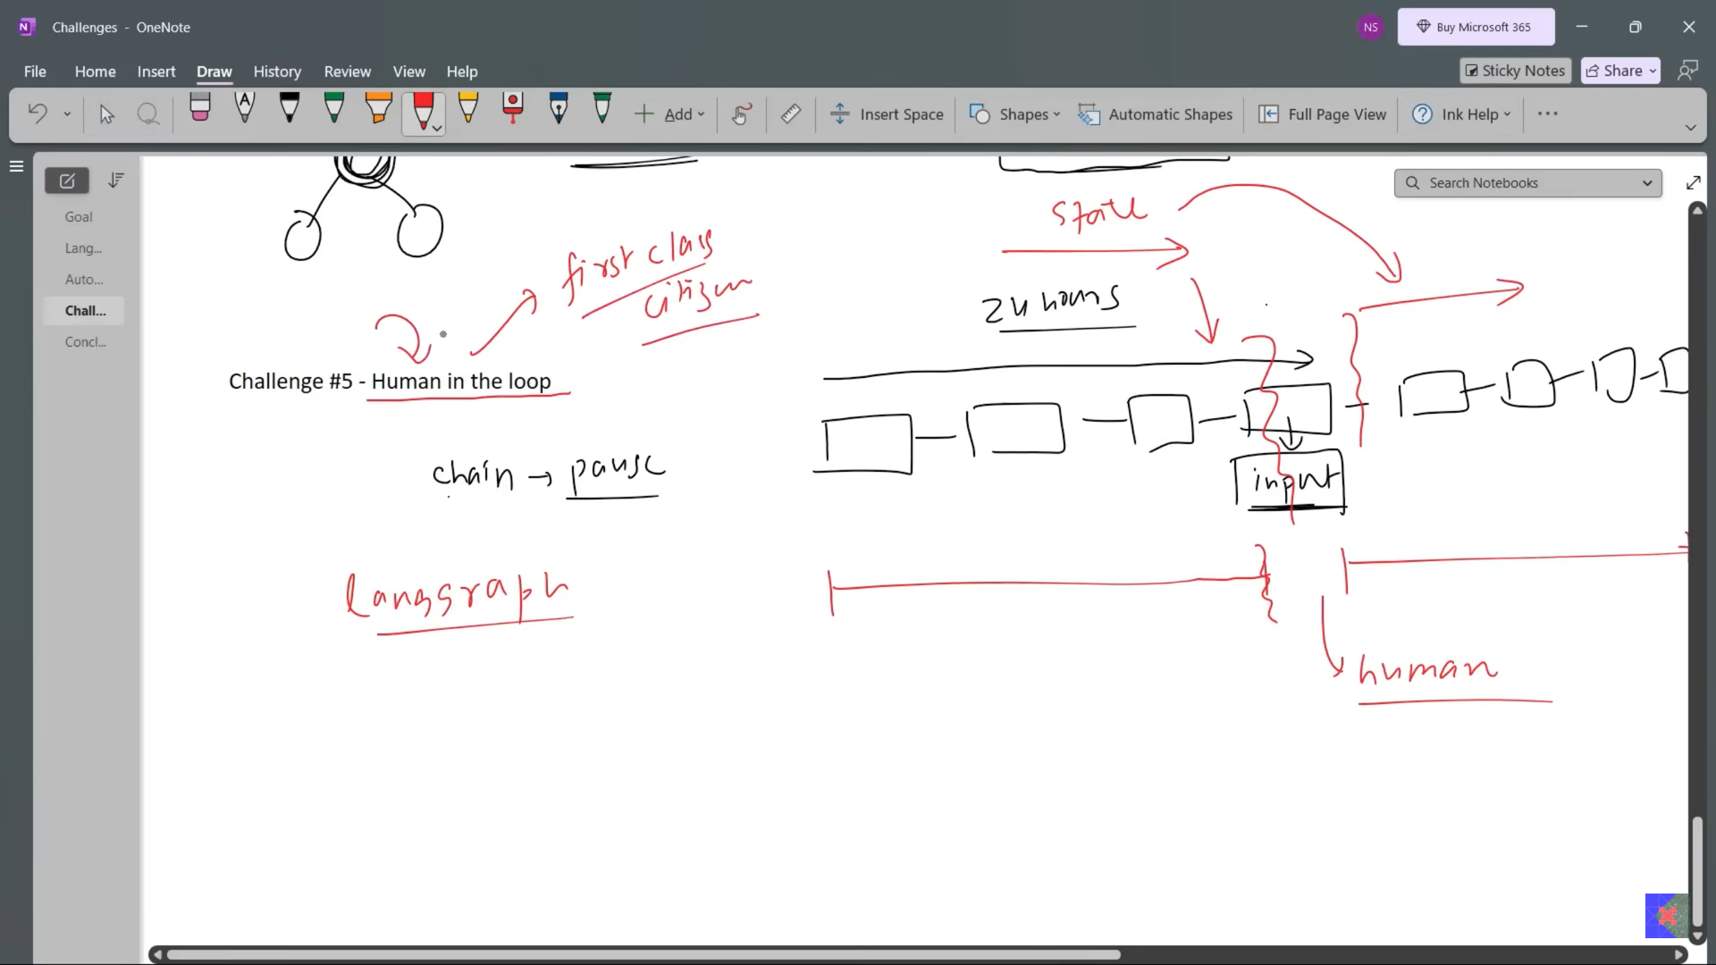

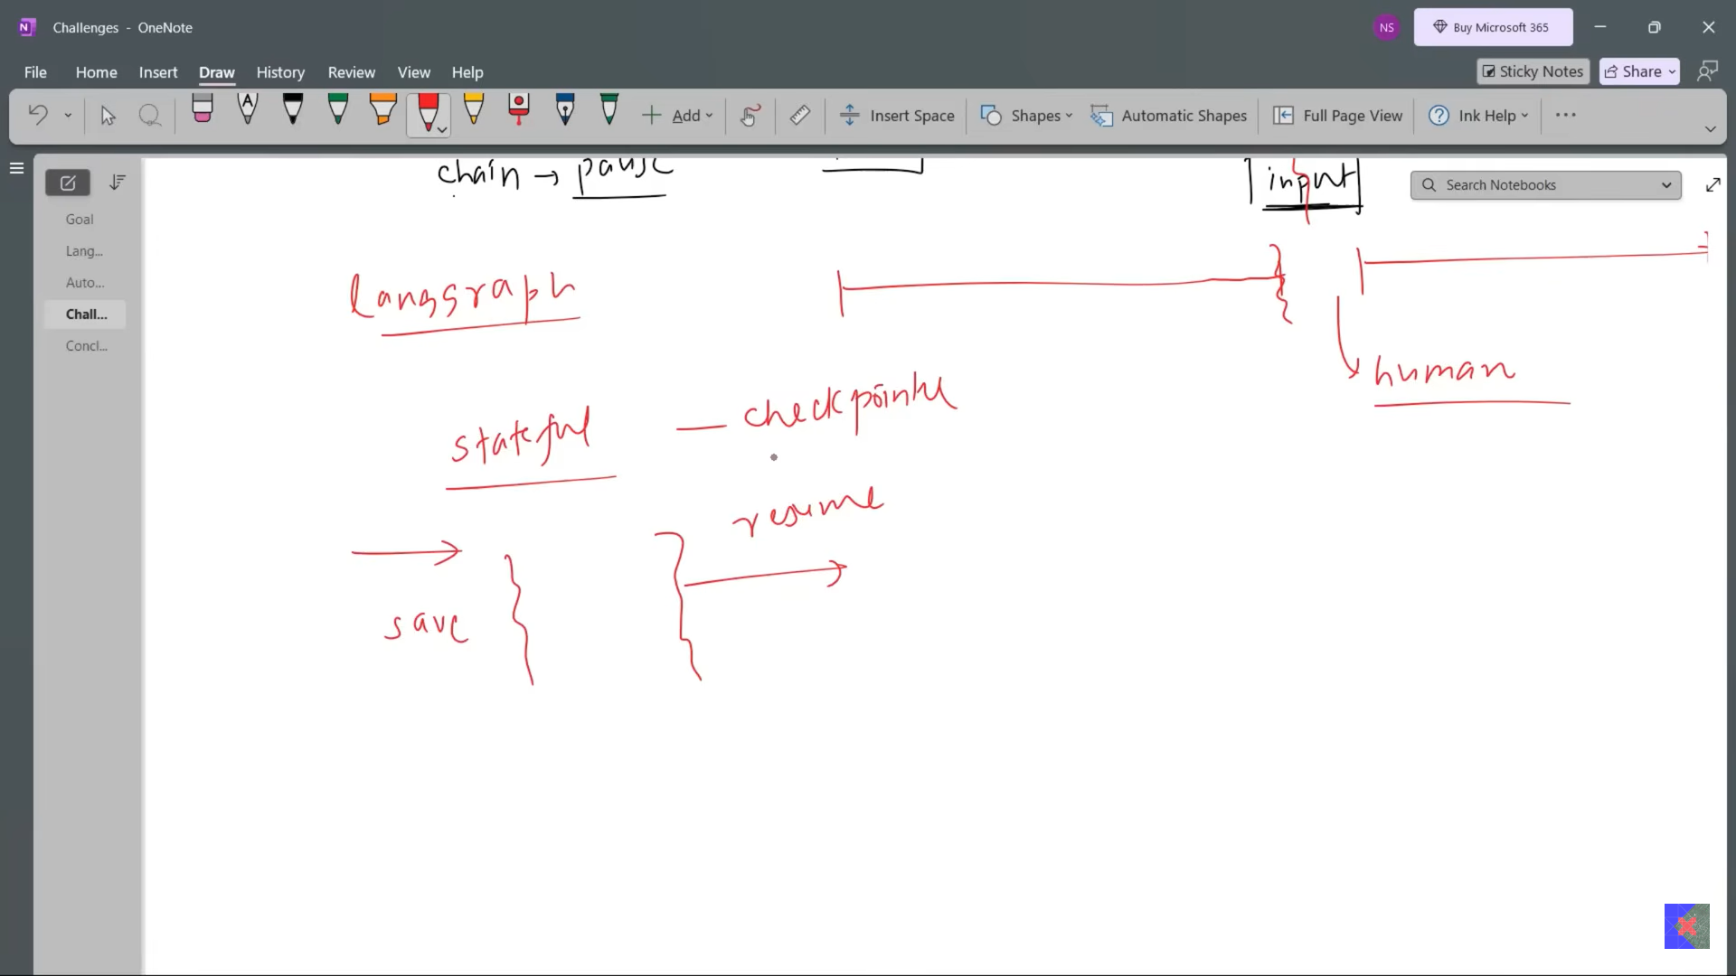

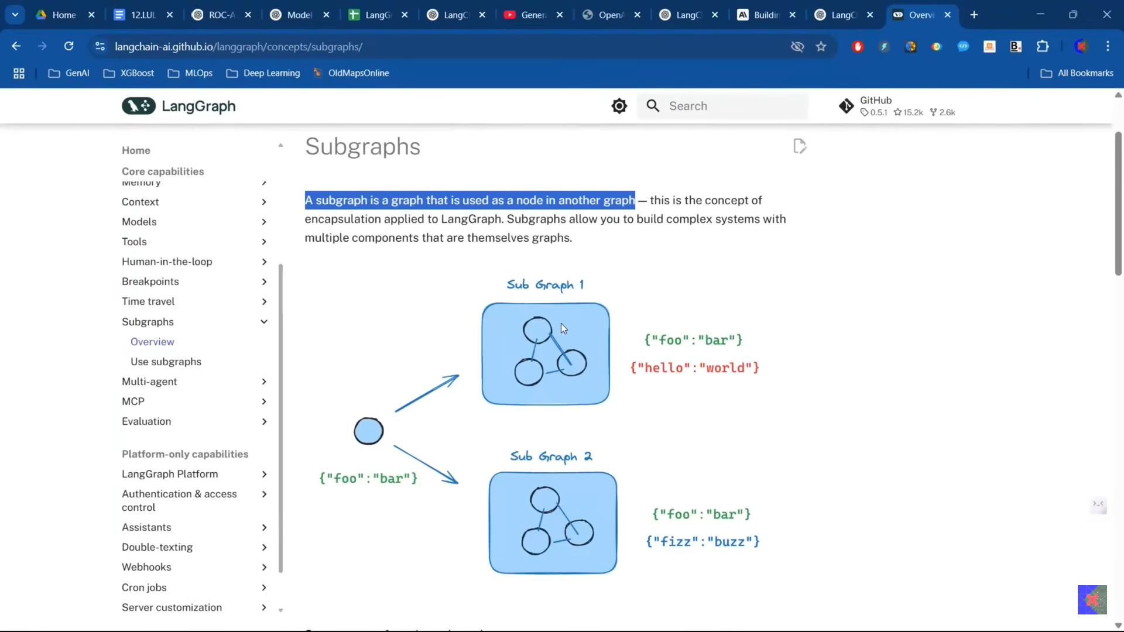

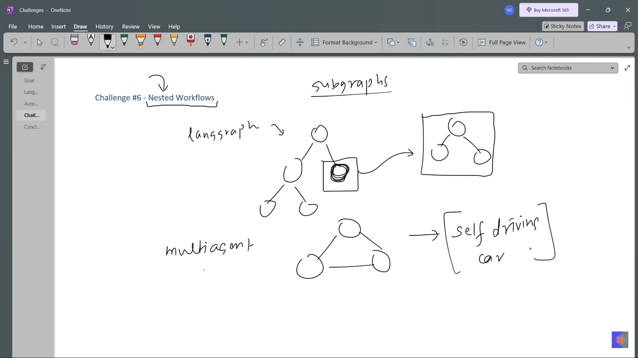

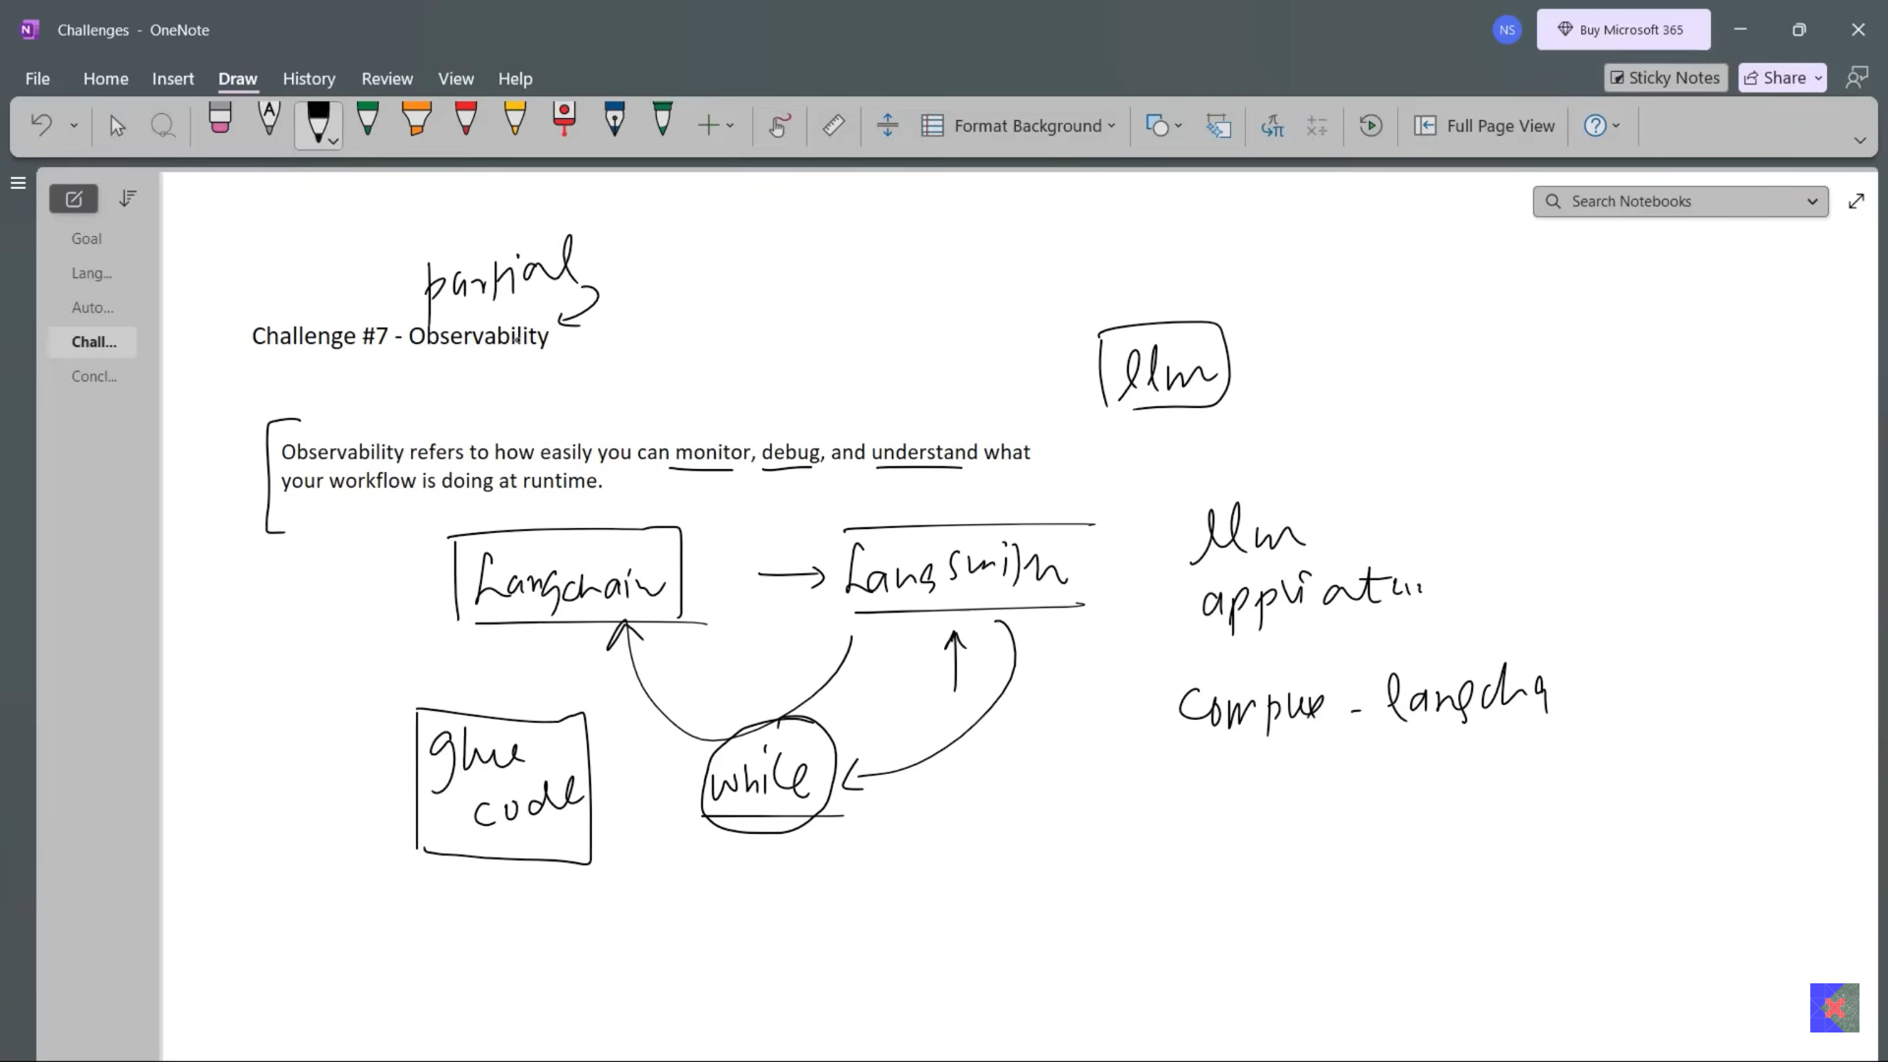

LangChain me partial observability hoti hai glue code track nhi kar pata hai LangSmith while LangGraph me sub node hi hai to LangSmith proper track 100% kar pata hai.

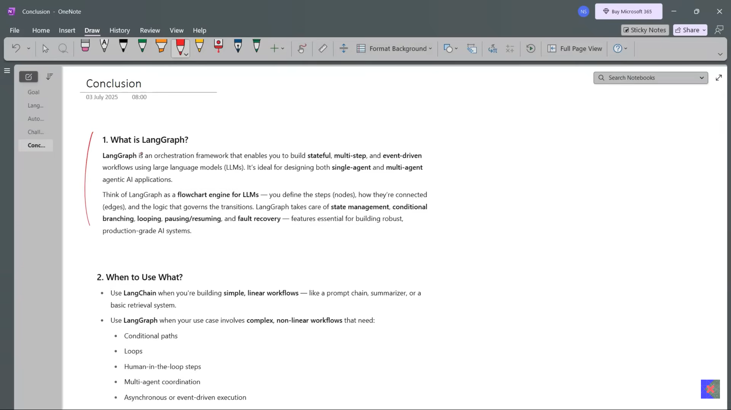



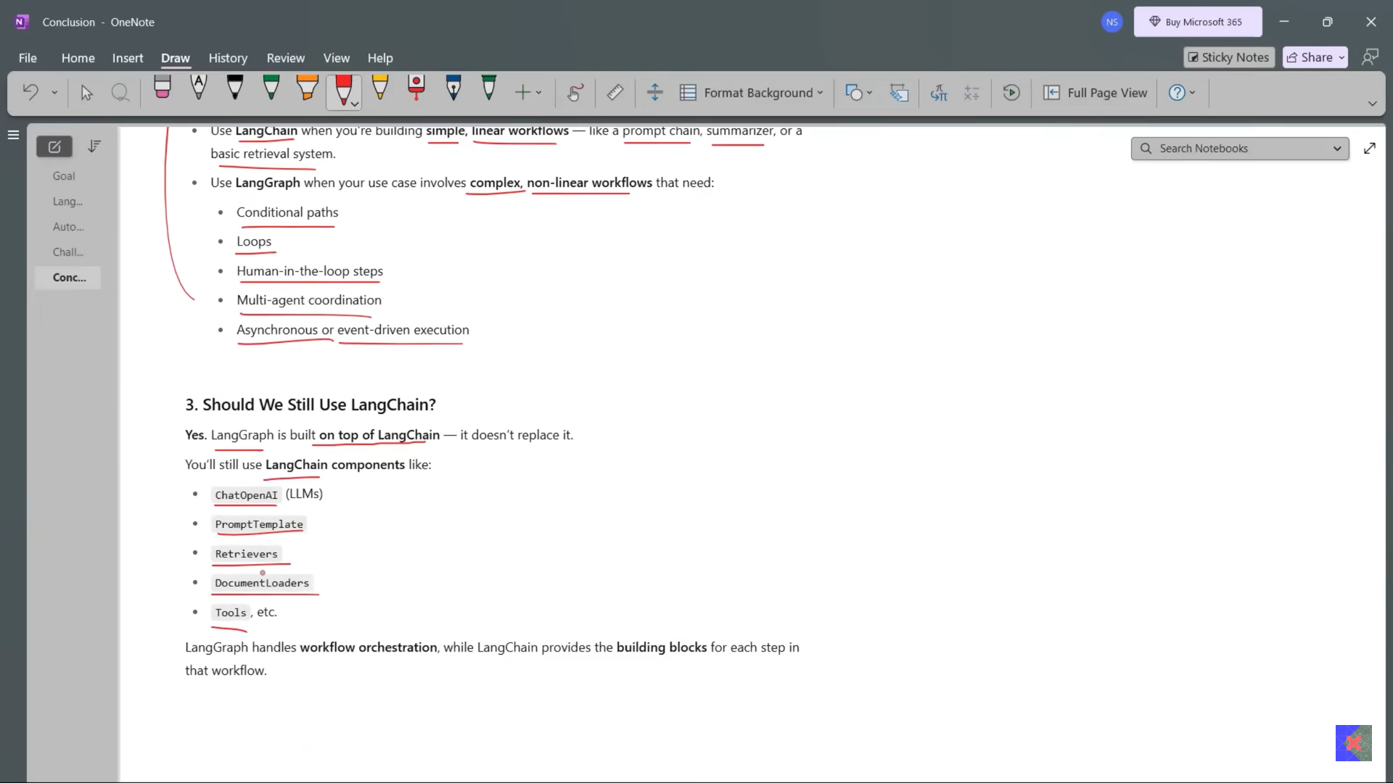

**LangGraph Core Concepts | Agentic AI using LangGraph | Video 4 | CampusX**

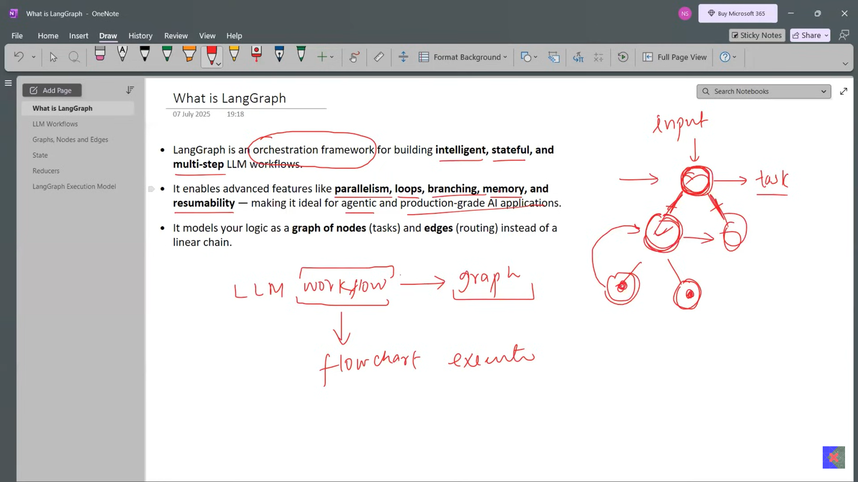

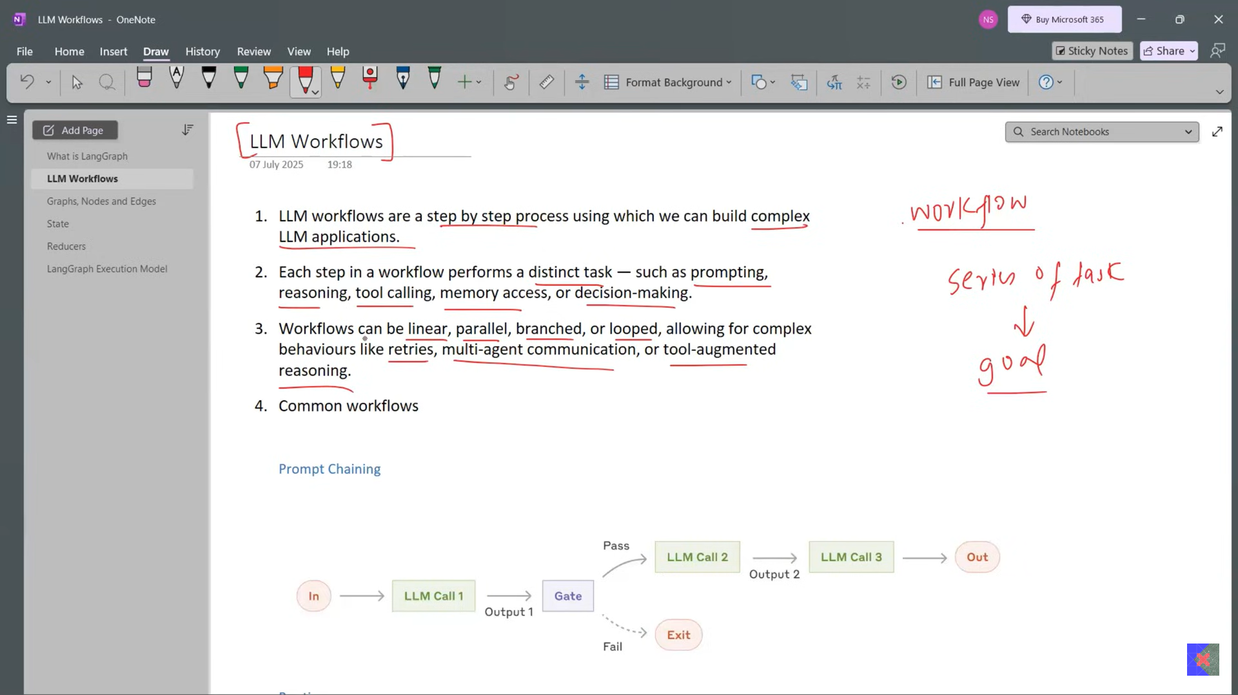

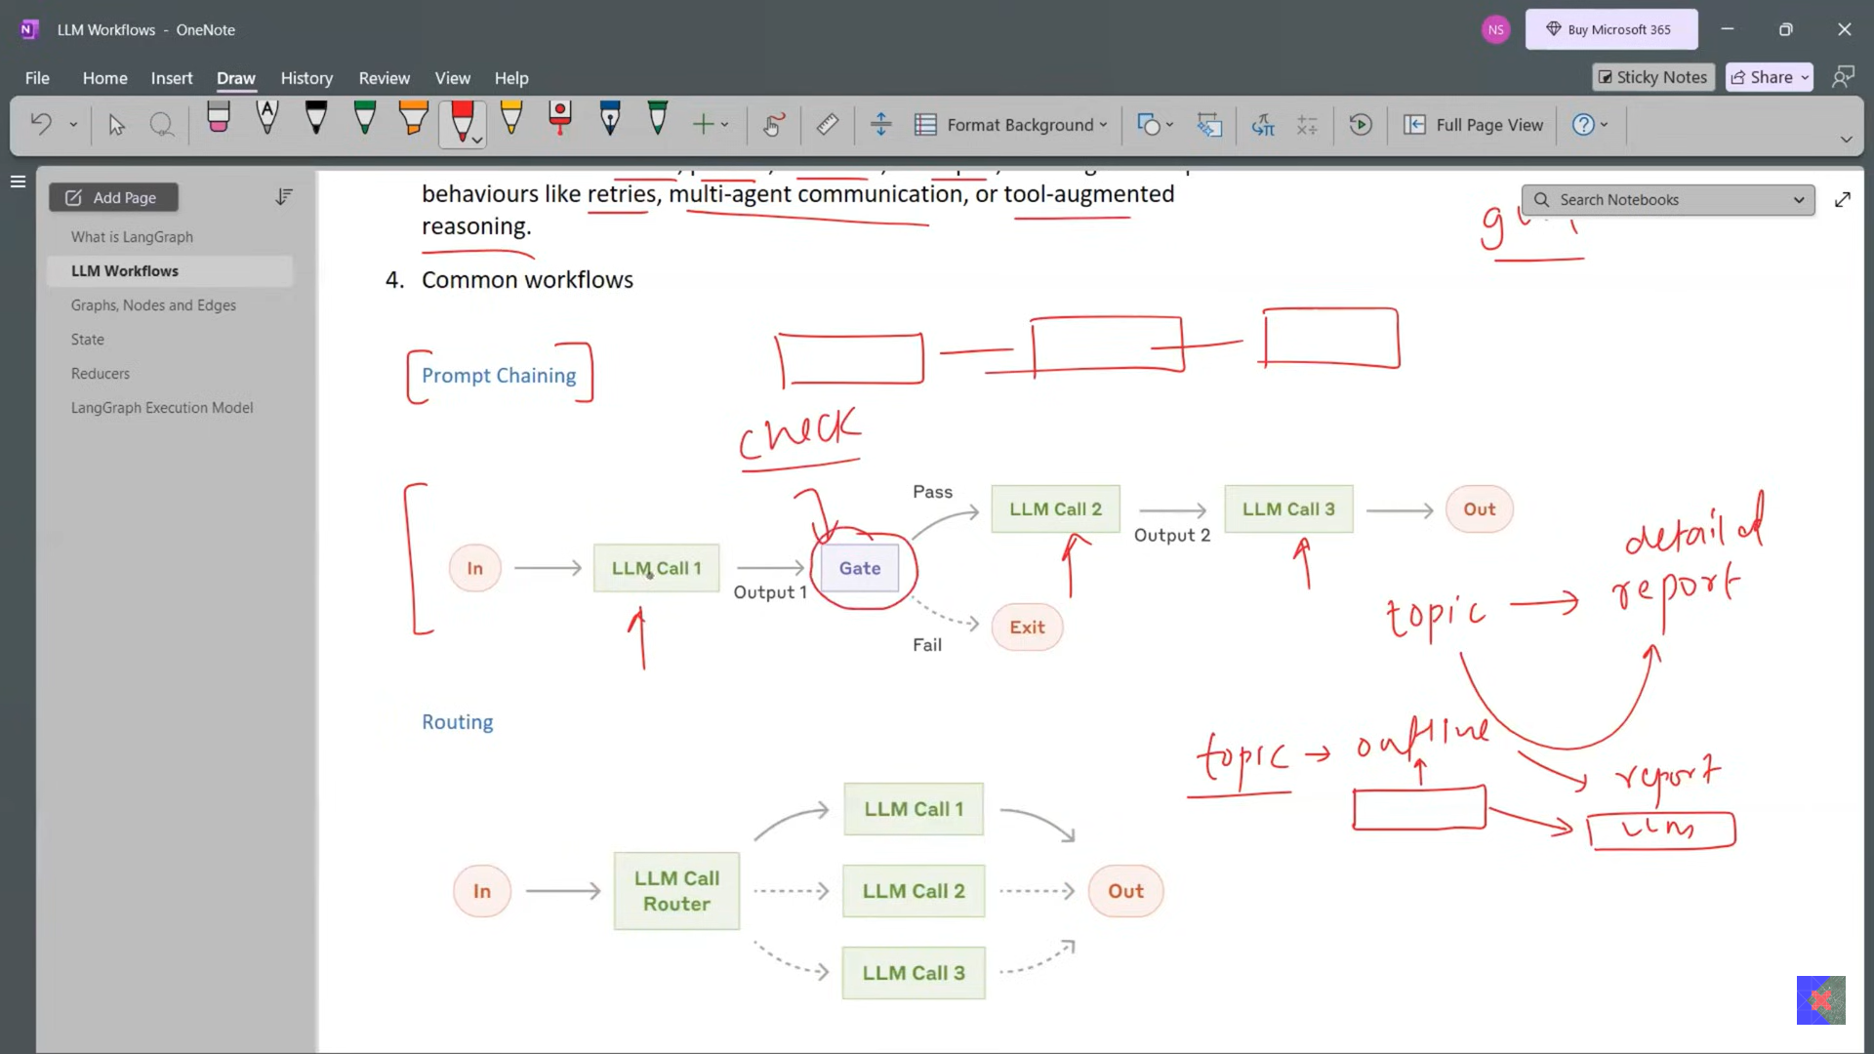

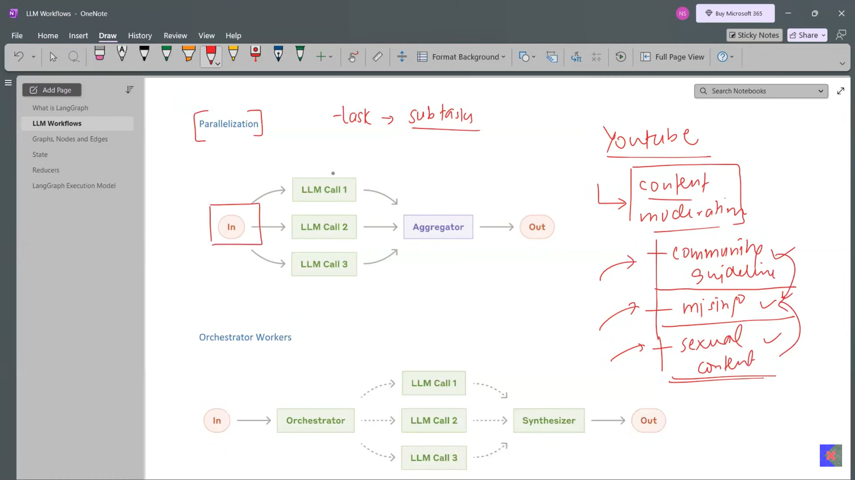

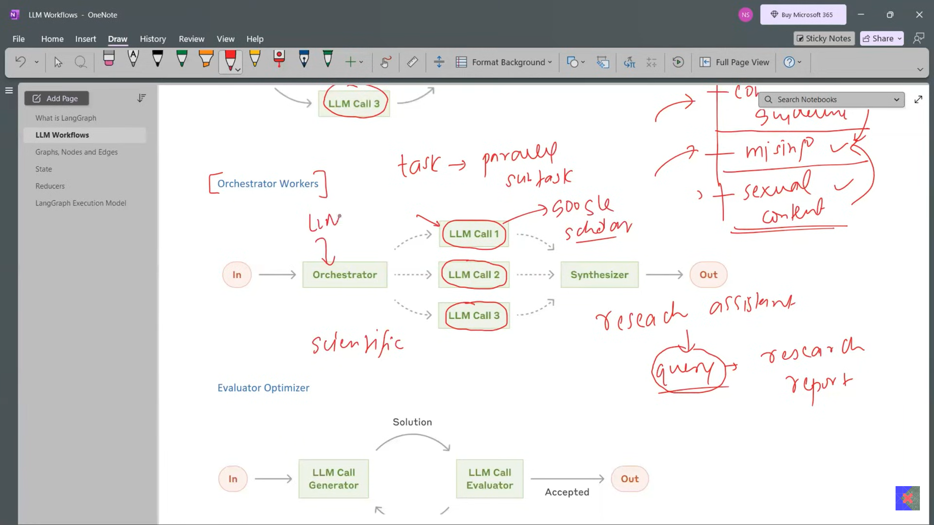

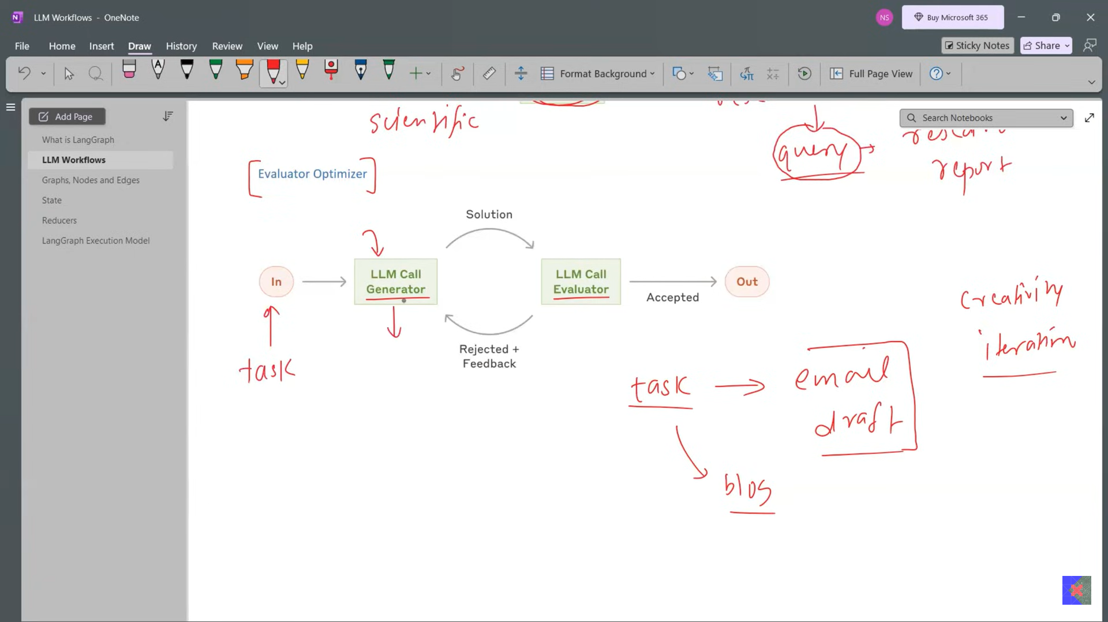

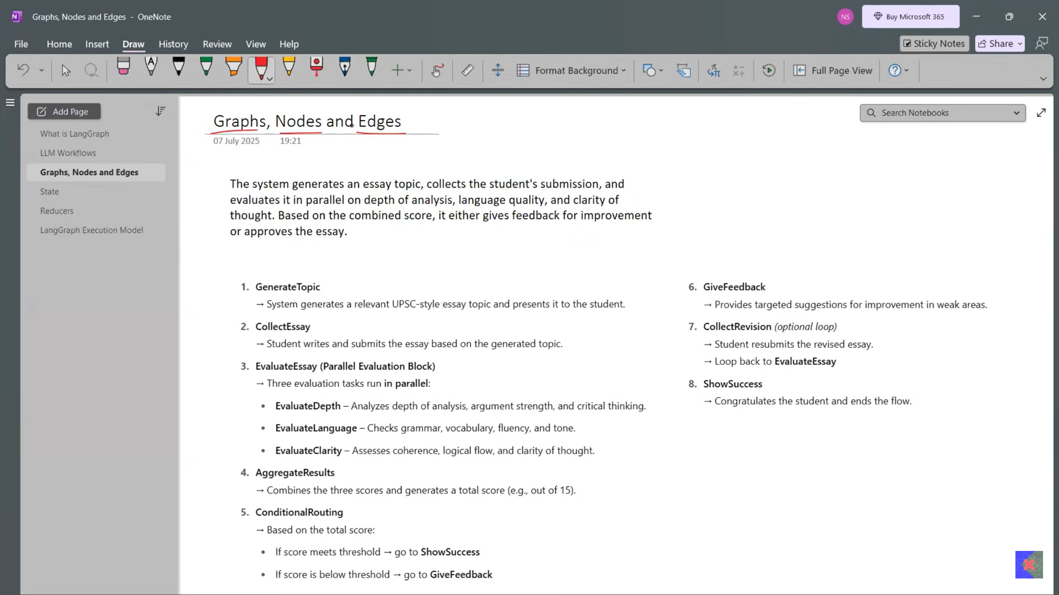

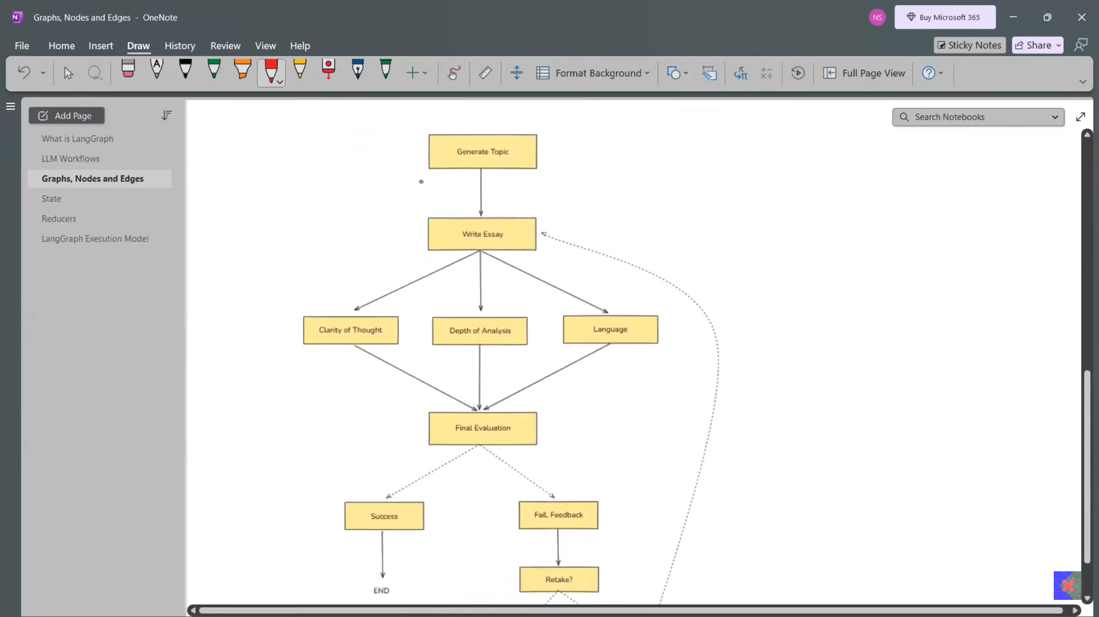

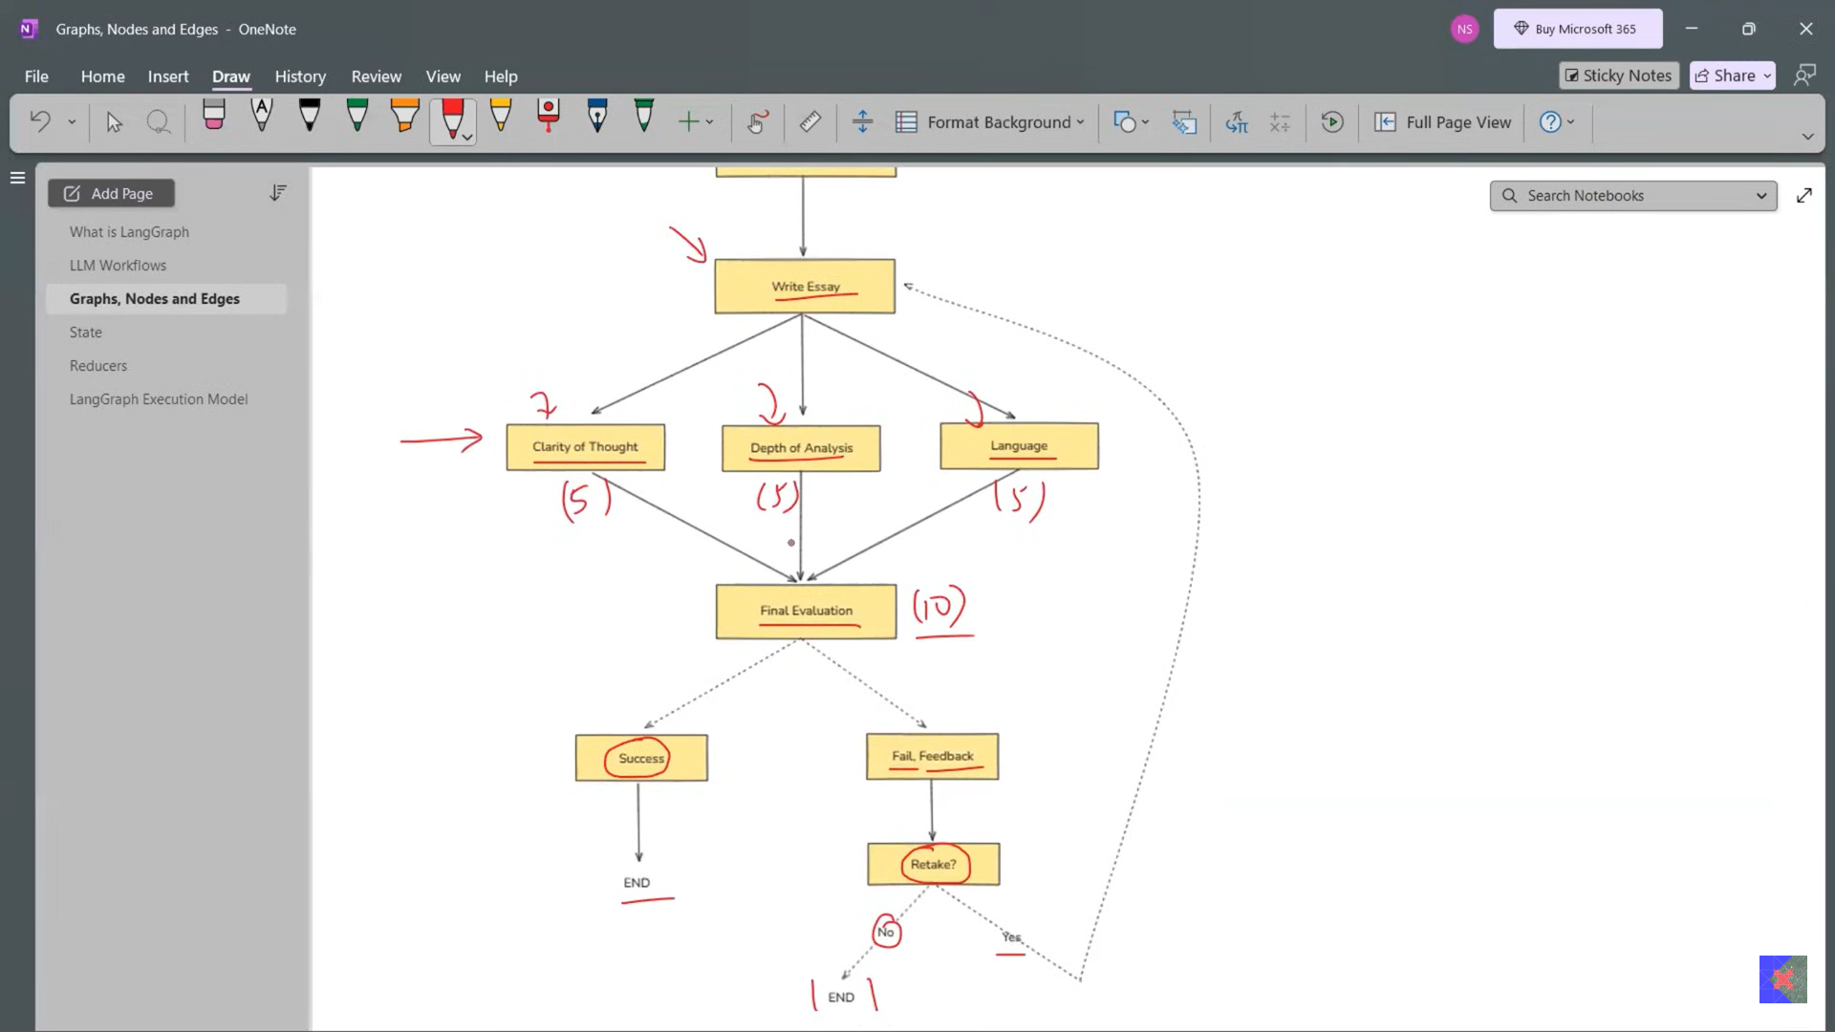

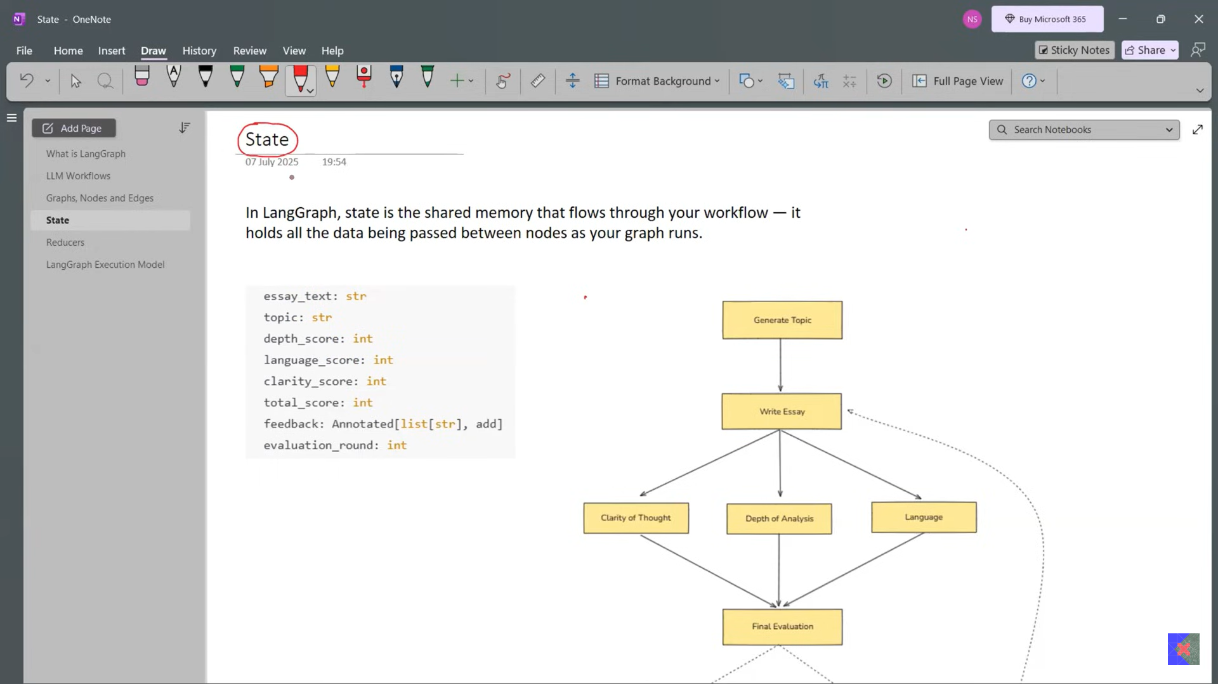

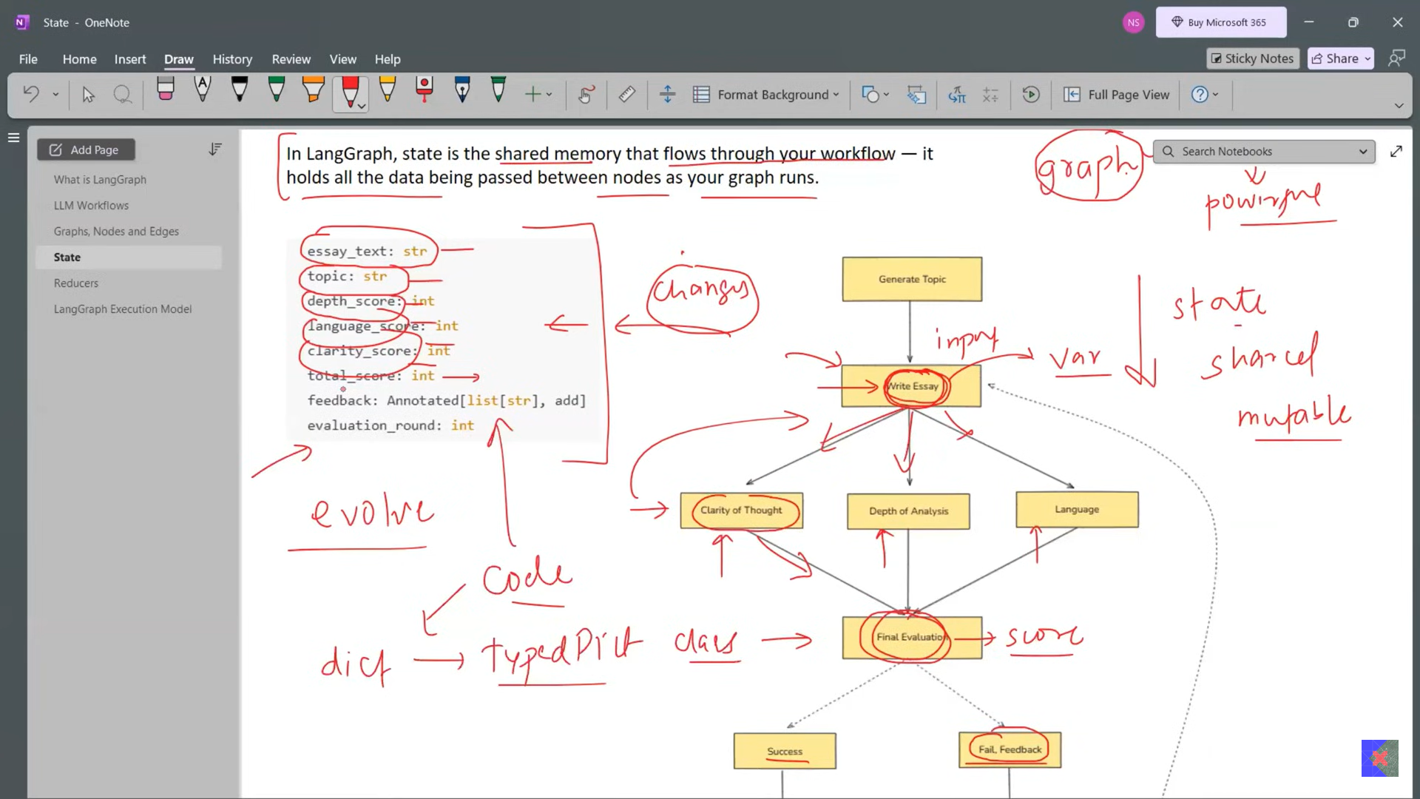

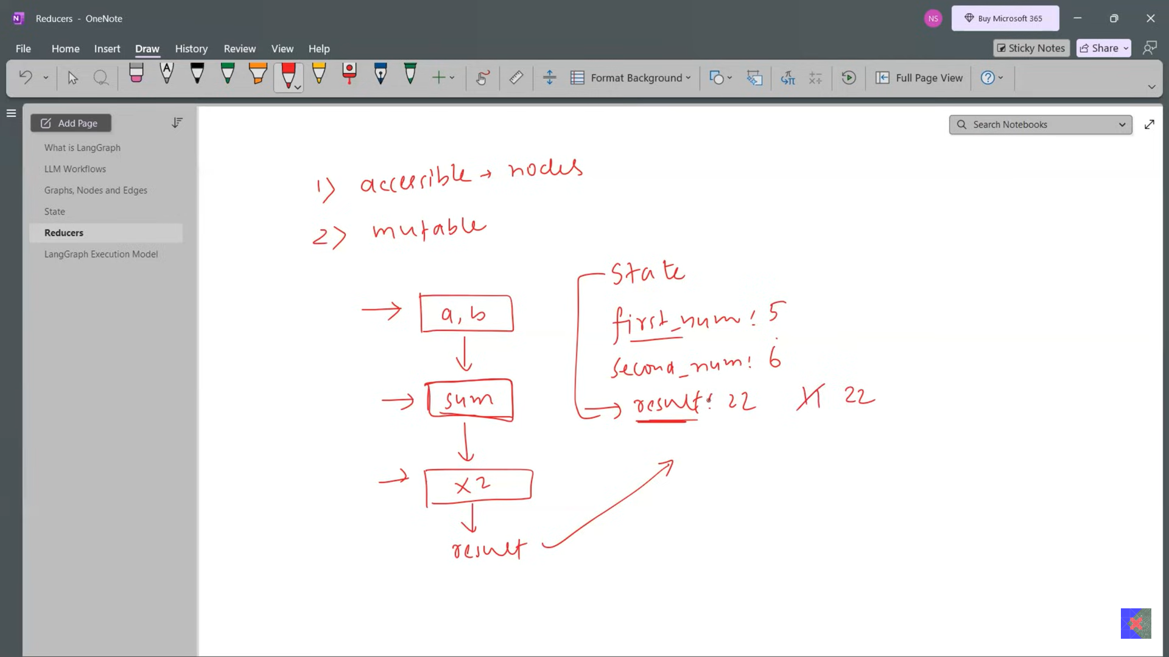

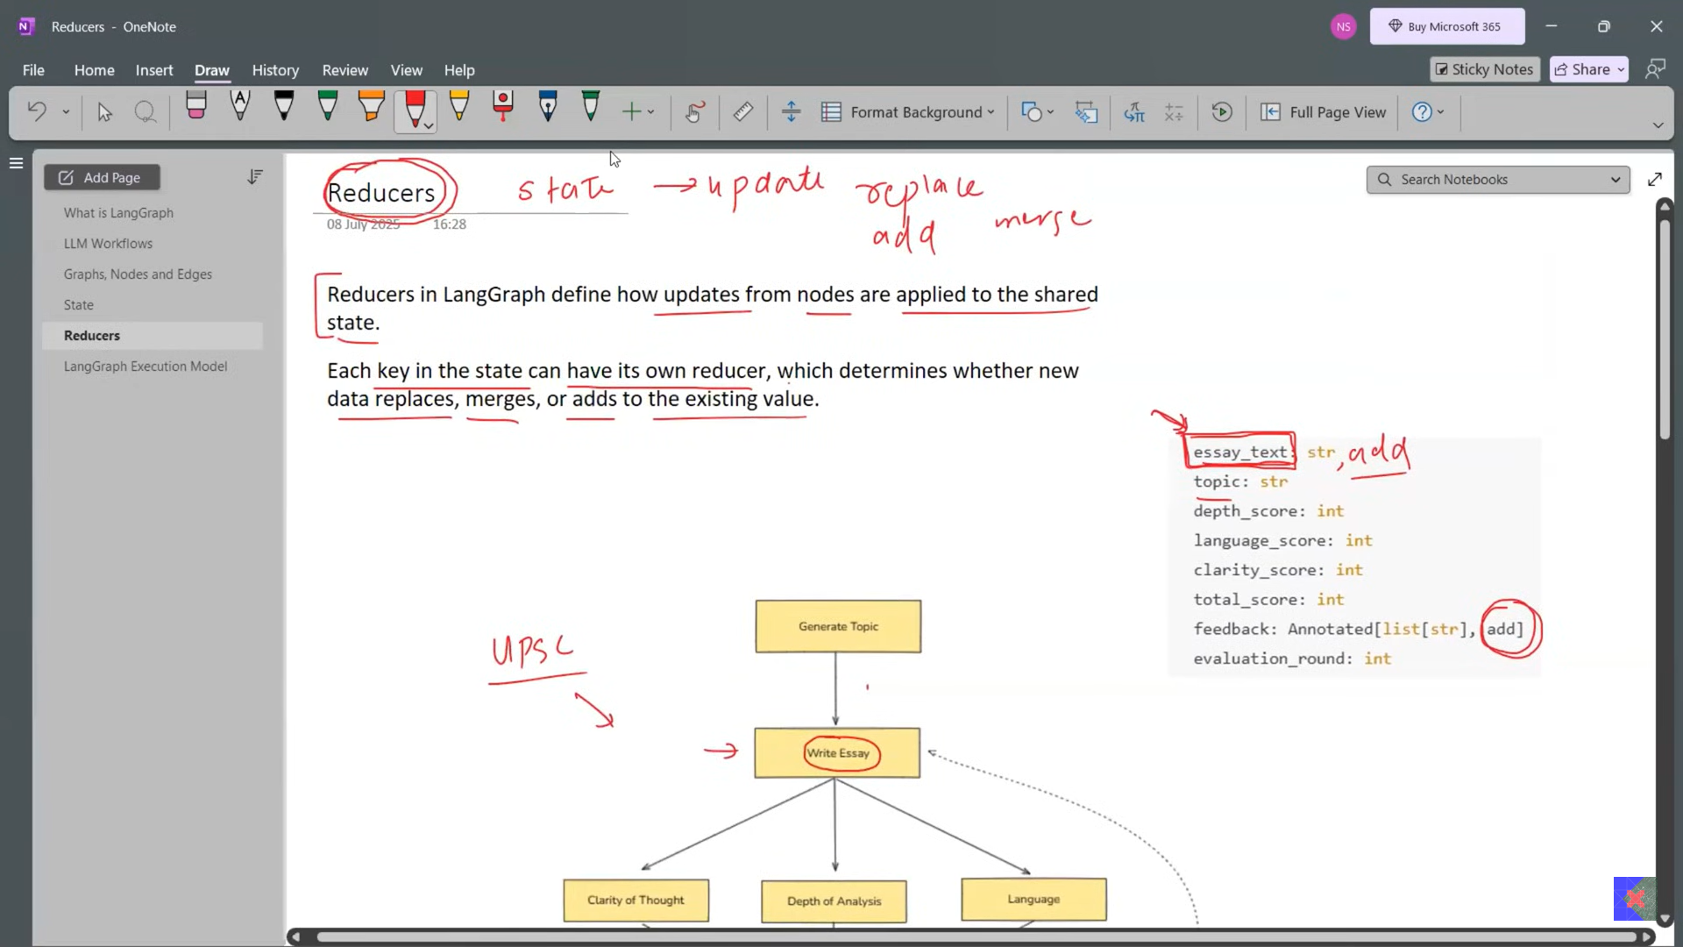

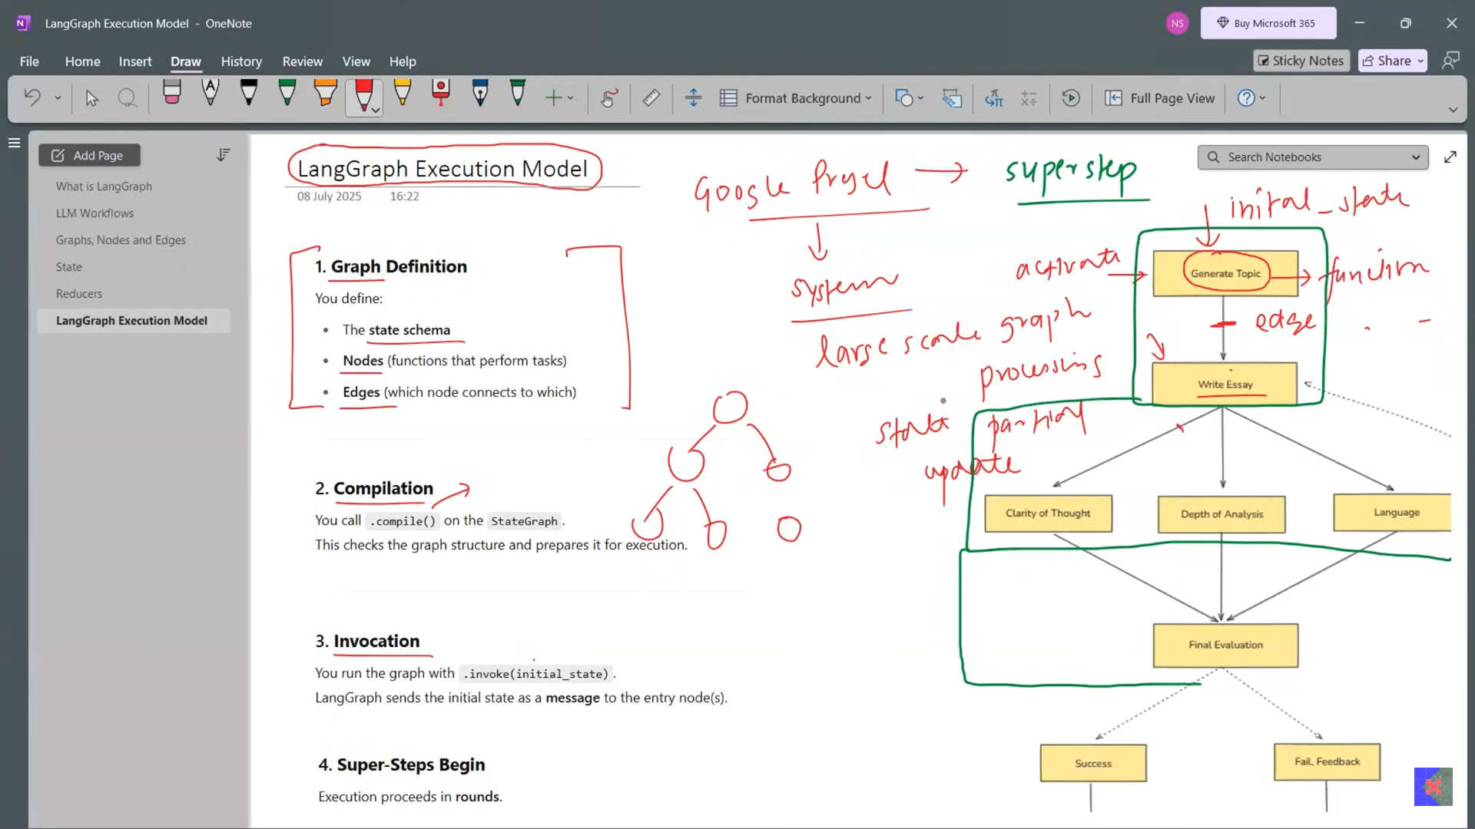

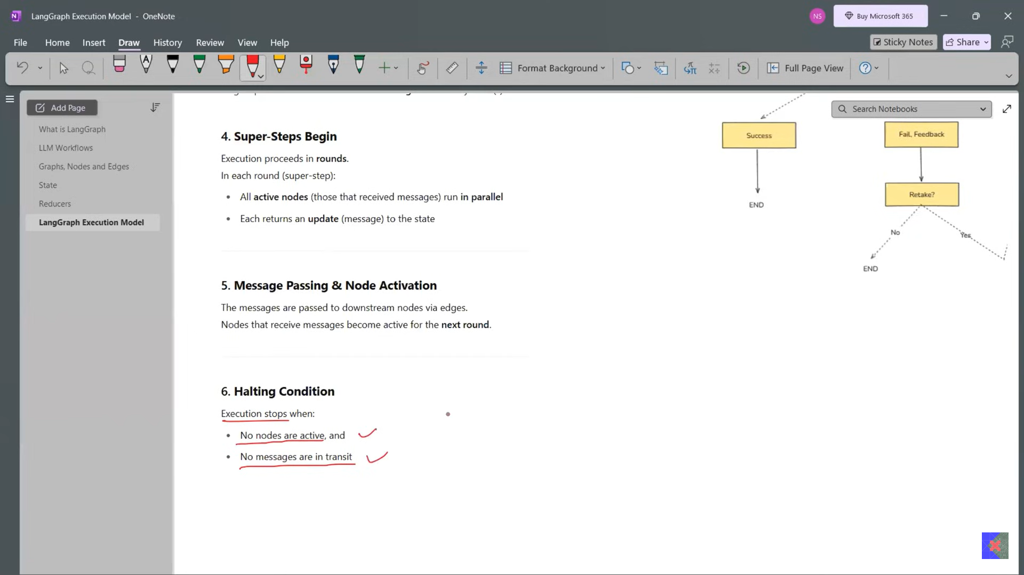

**Sequential Workflows in LangGraph | Agentic AI using LangGraph | Video 5 | CampusX**

Code: <https://github.com/campusx-official/langgraph-tutorials>

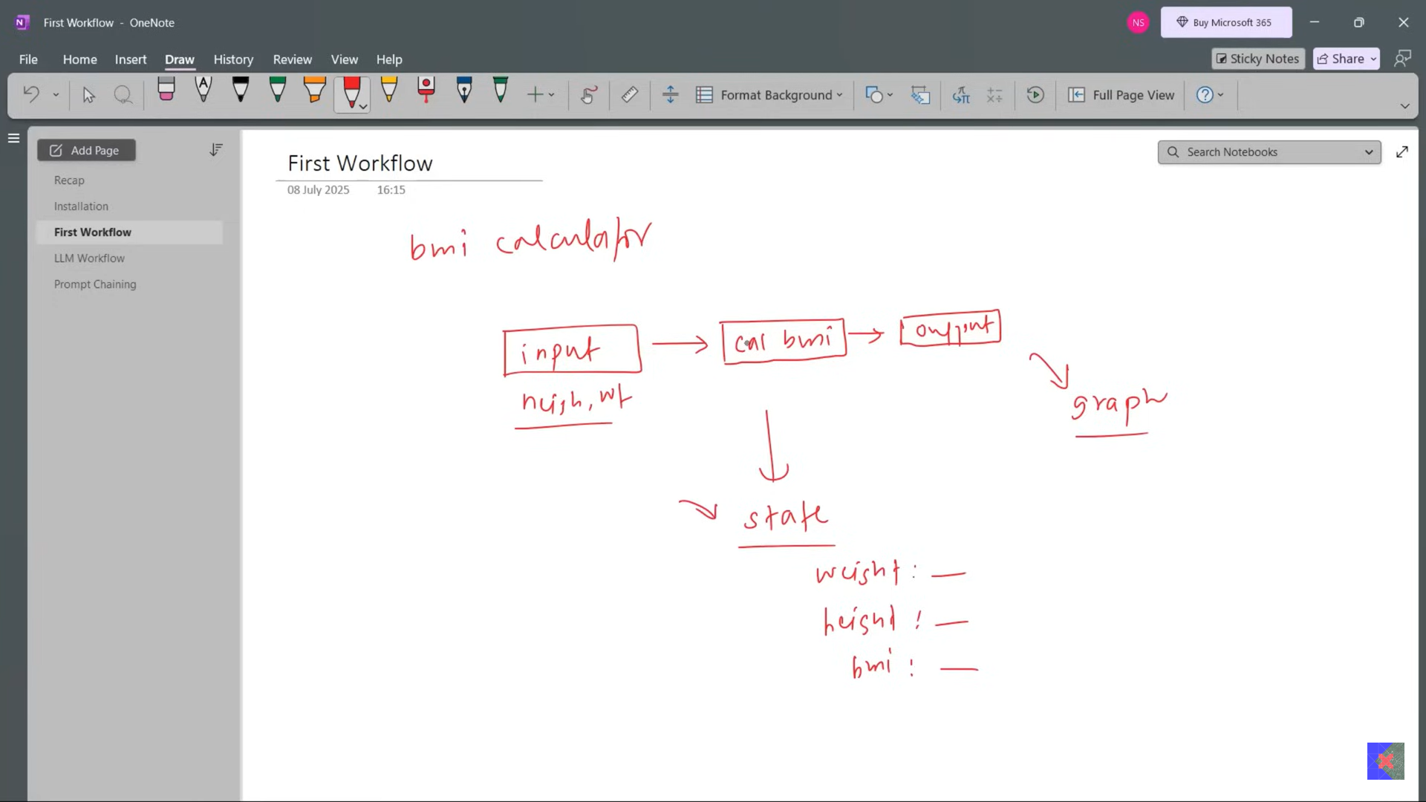

1_bmi_workflow.ipynb

2_simple_llm_workflow.ipynb

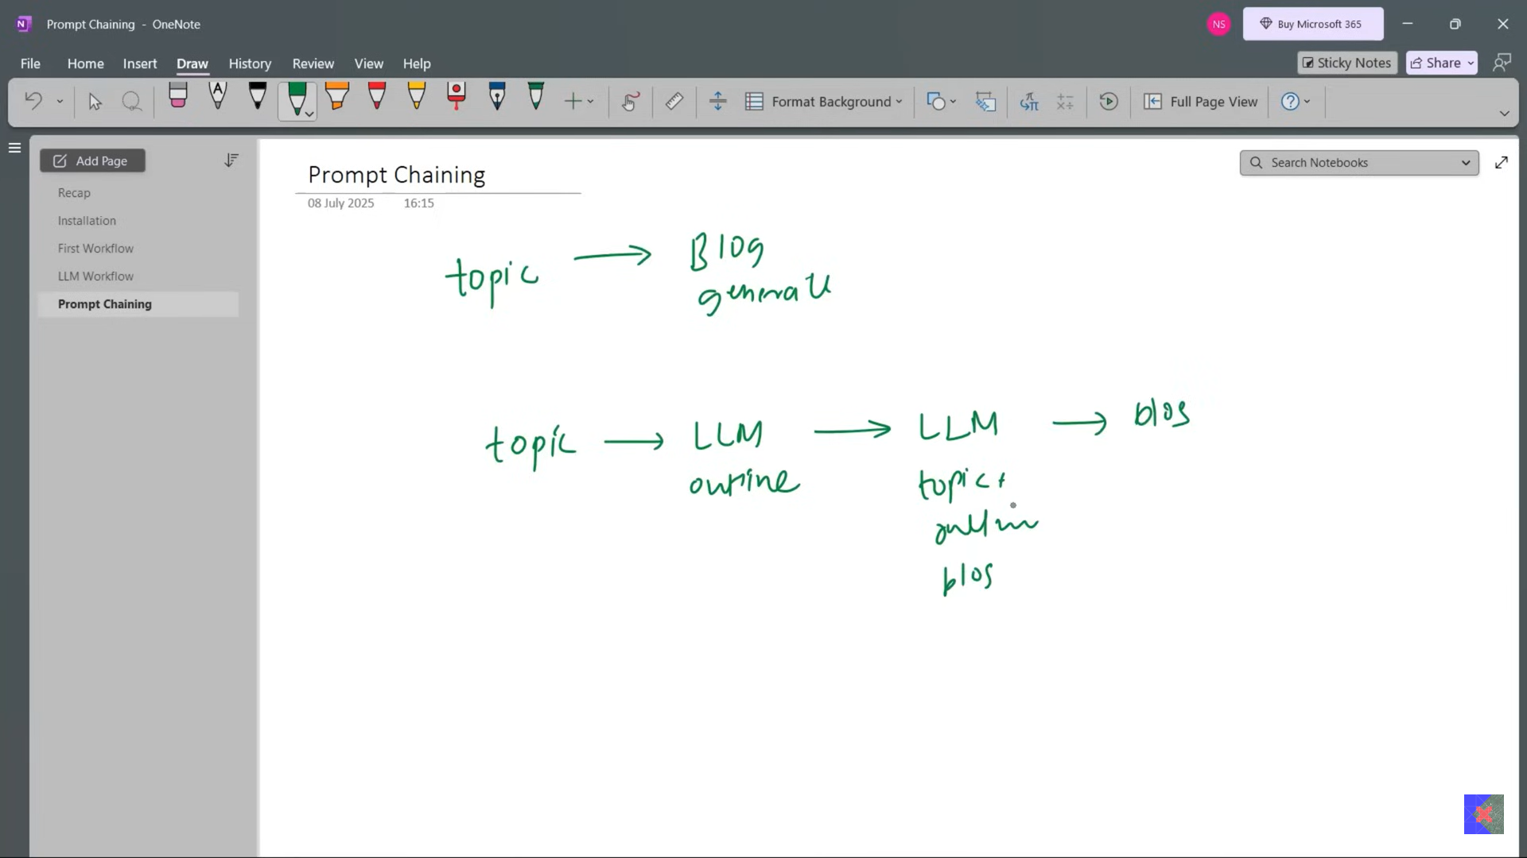

3_prompt_chaining.ipynb

**Parallel Workflows in LangGraph | Agentic AI using LangGraph | Video 6 | CampusX**

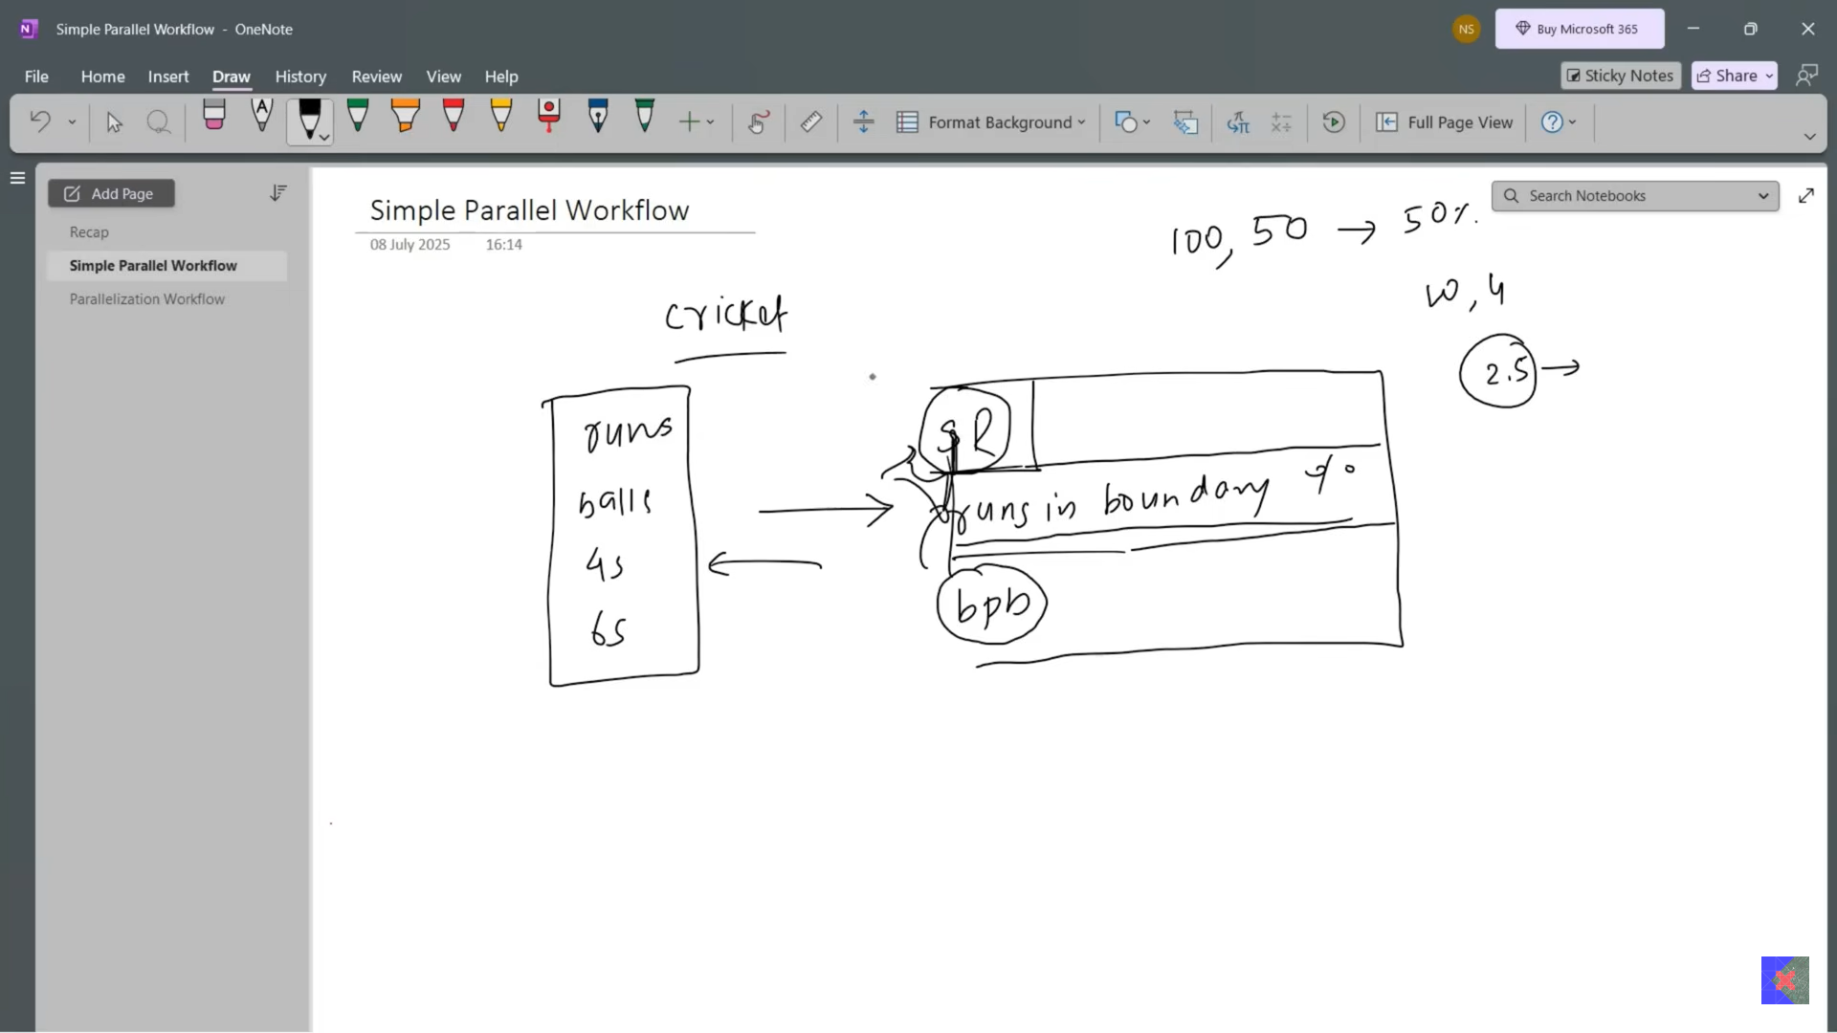

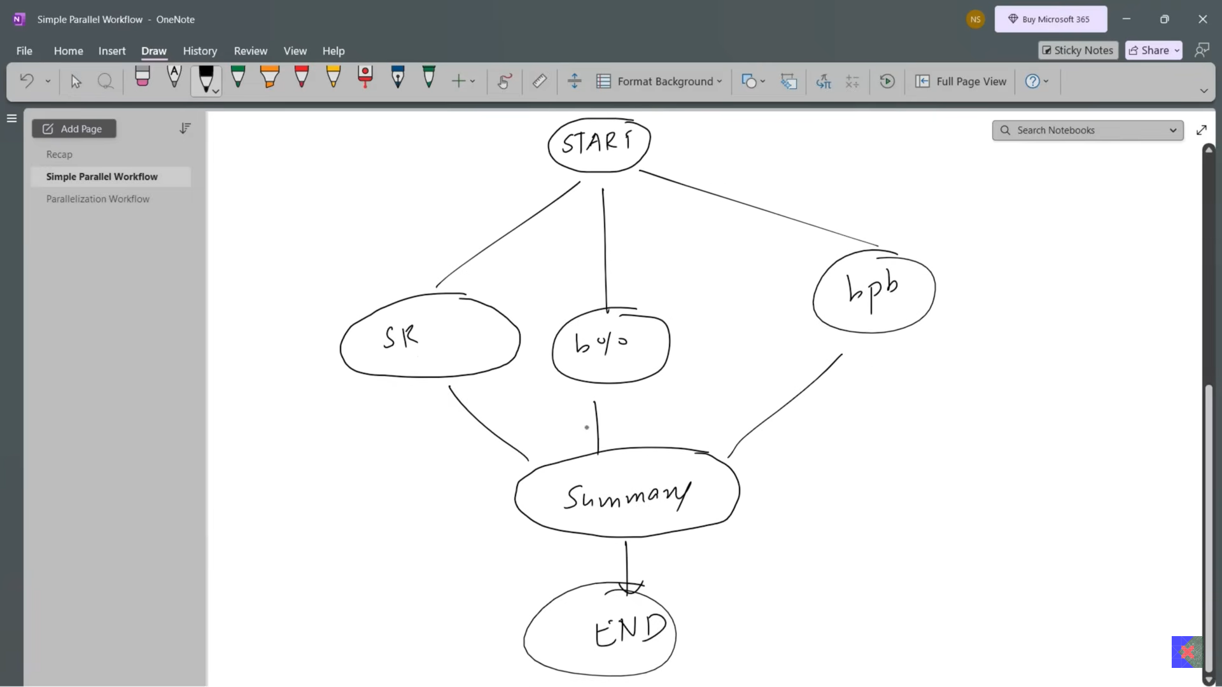

4_batsman_workflow.ipynb

Sequential ya paraller me partial state return thik hota hai.

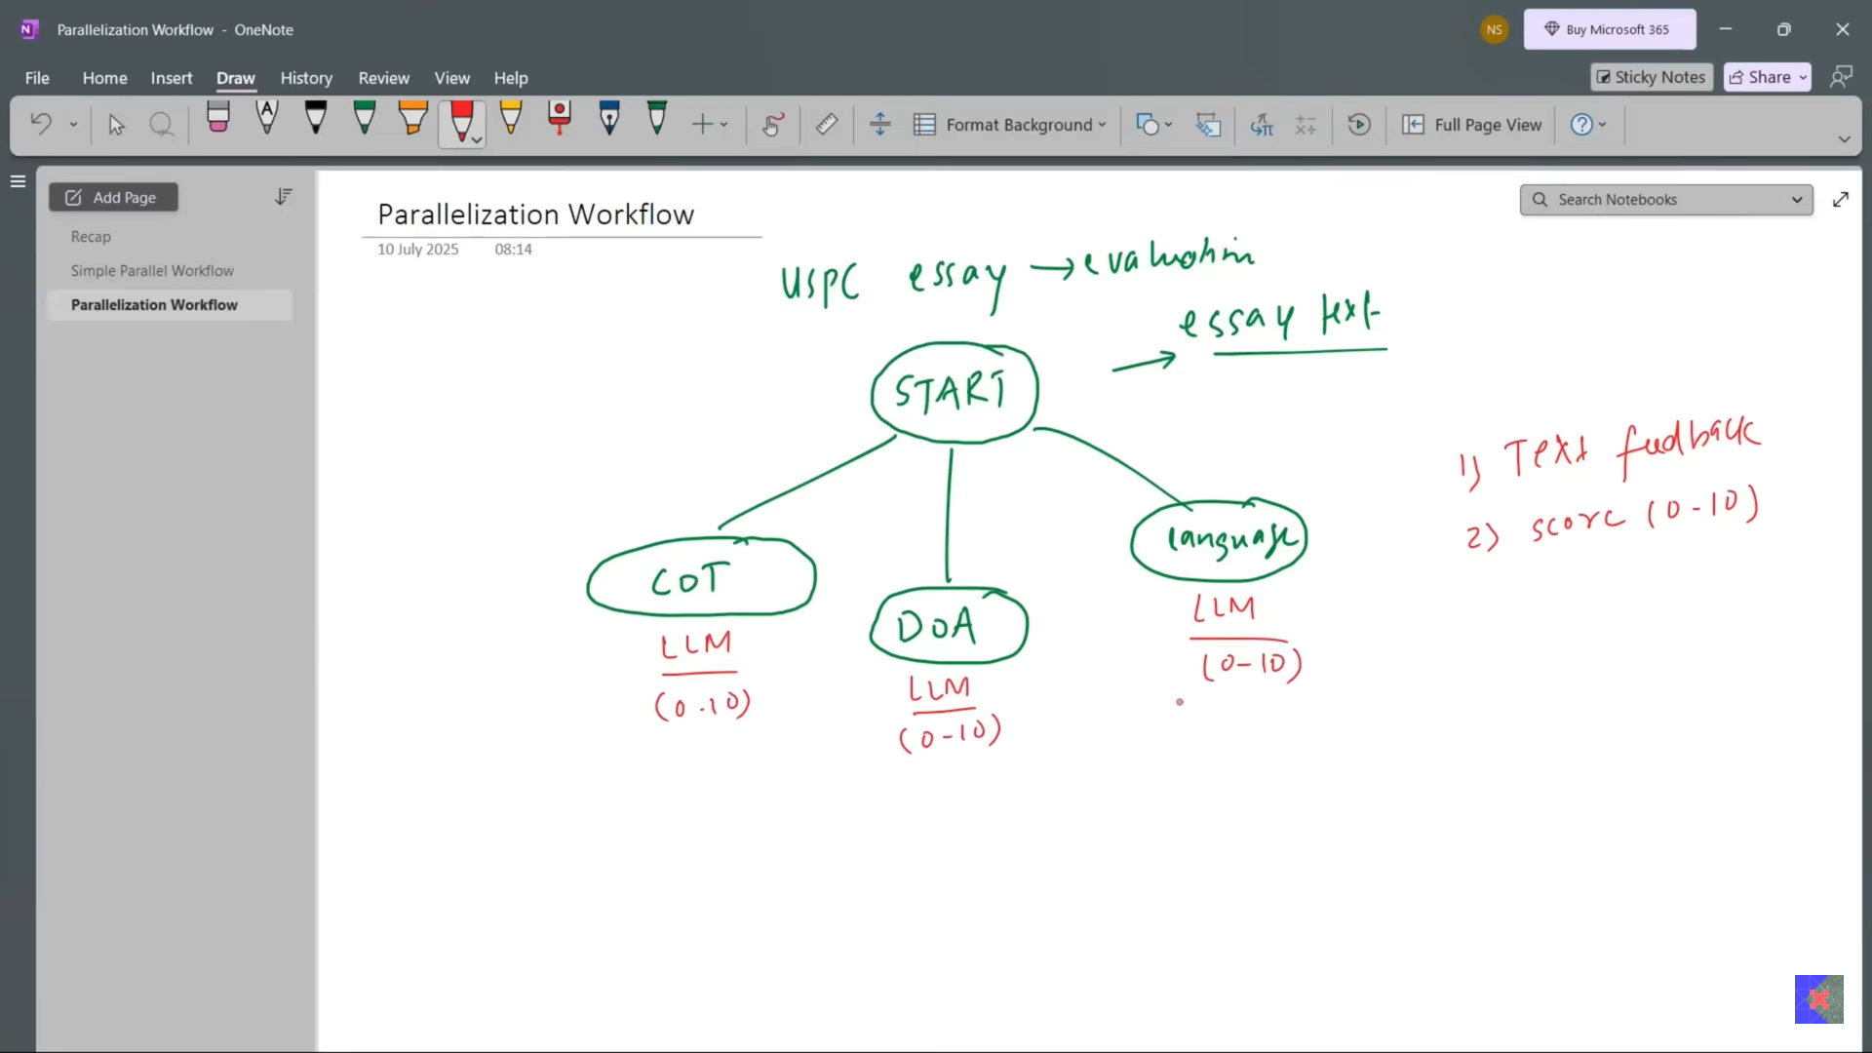

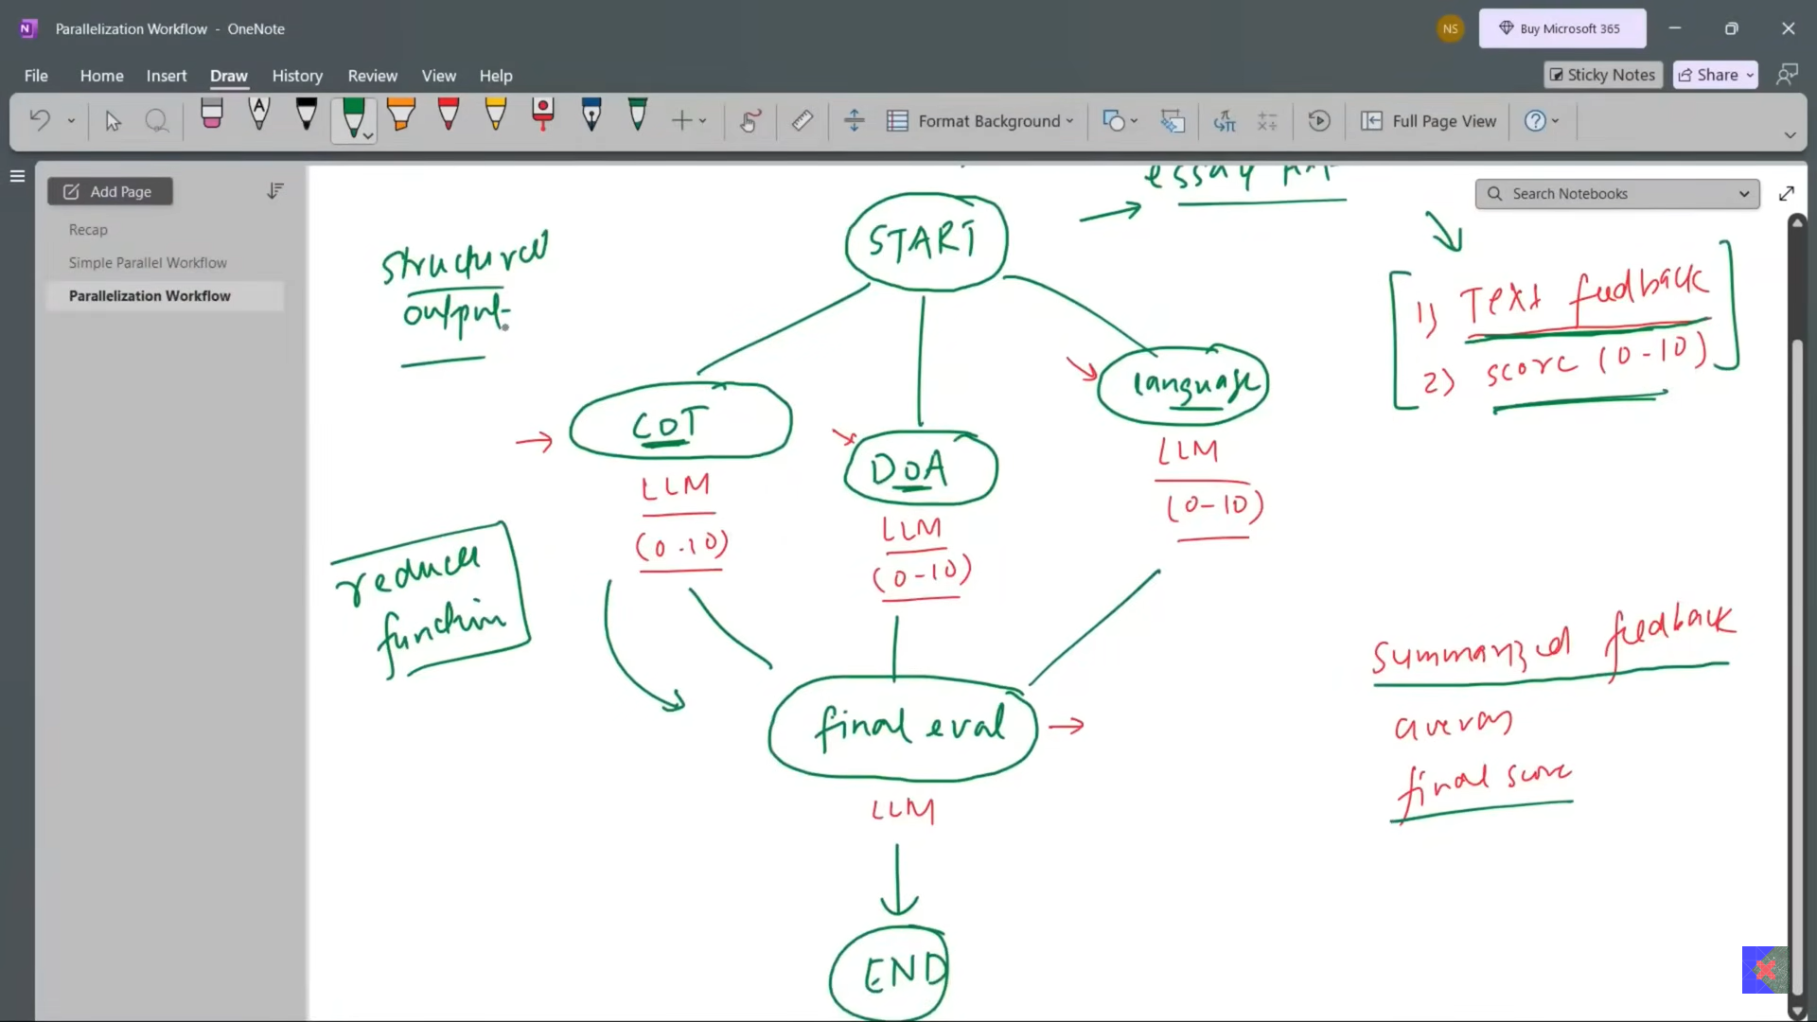

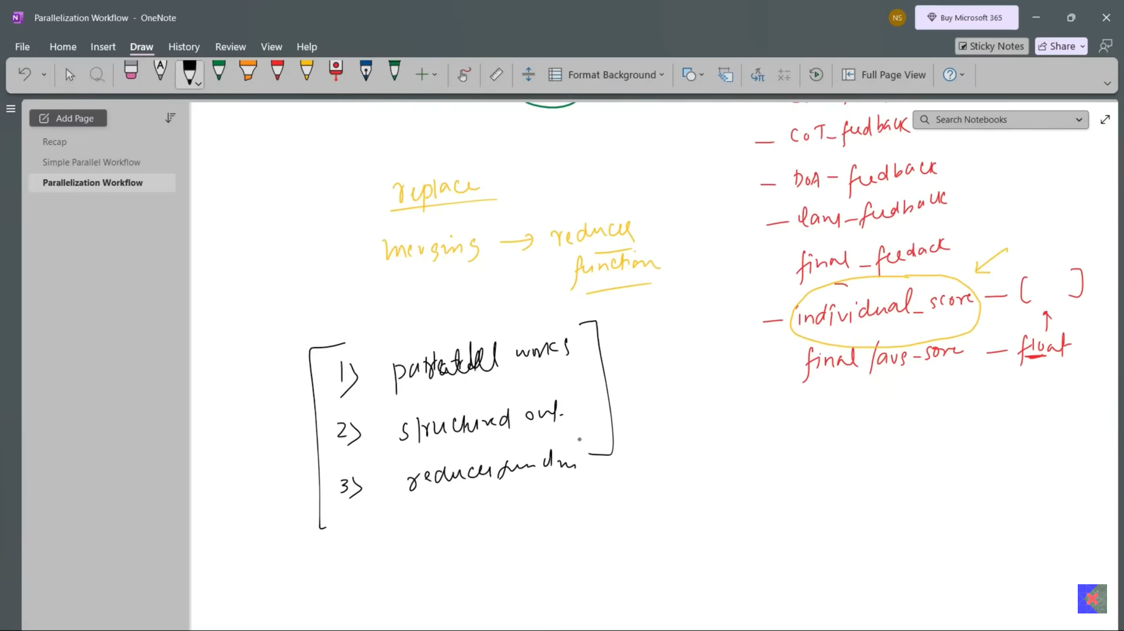

5_UPSC_essay_workflow.ipynb

**Conditional Workflows in LangGraph | Agentic AI using LangGraph | Video 7 | CampusX**

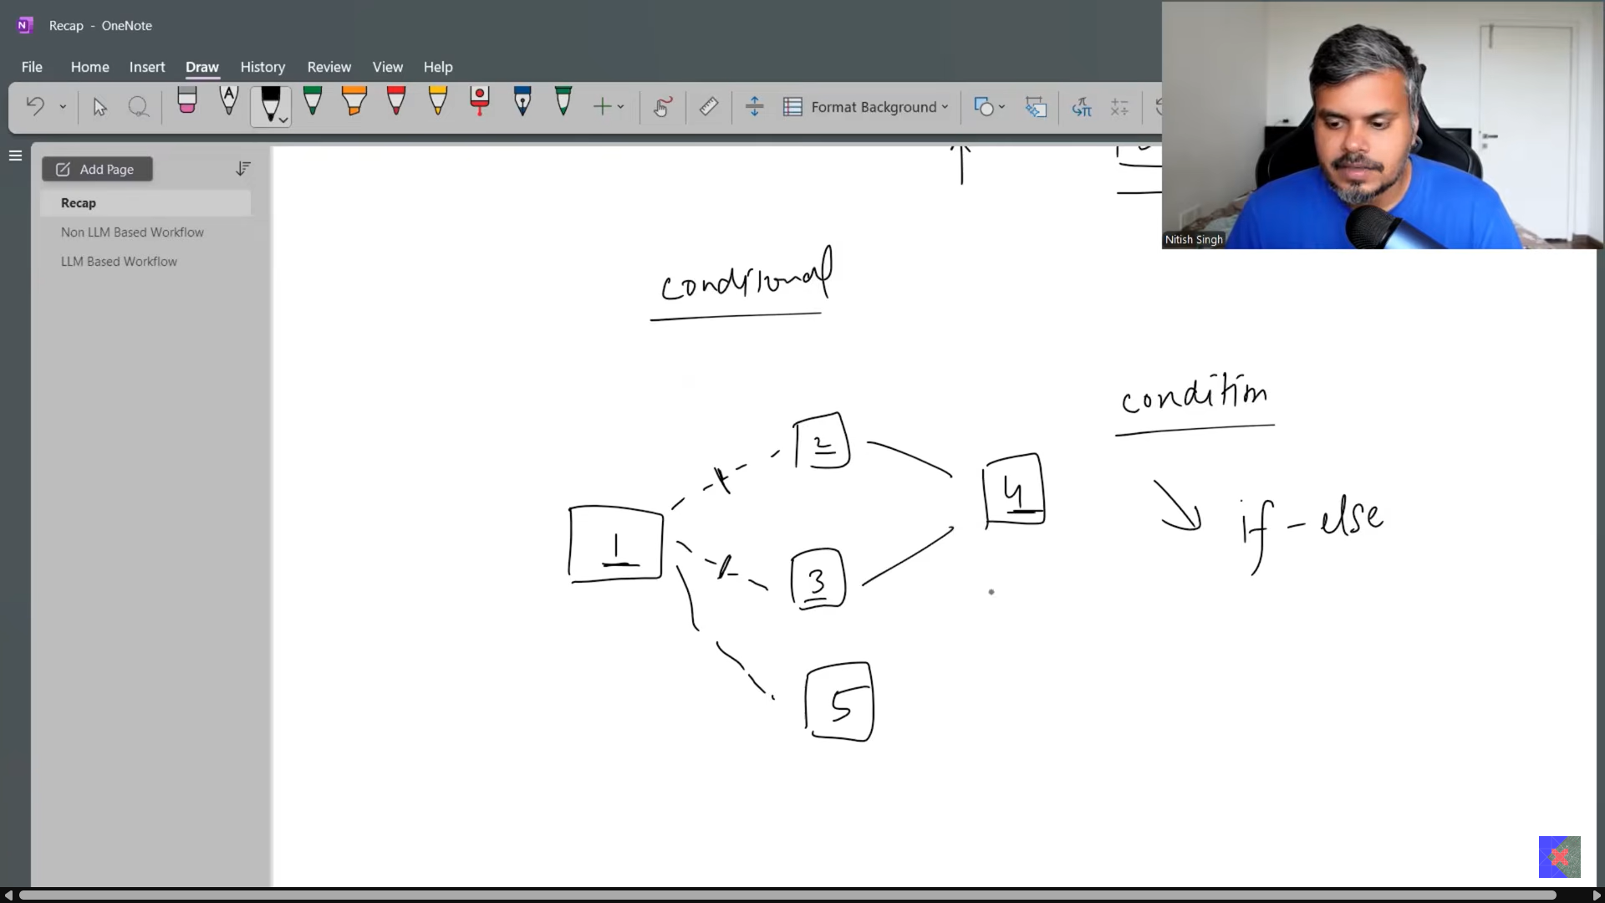

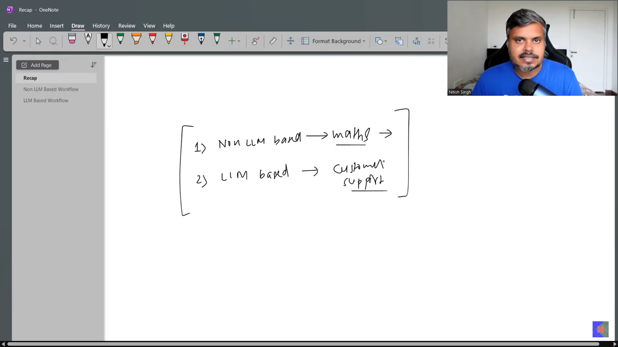

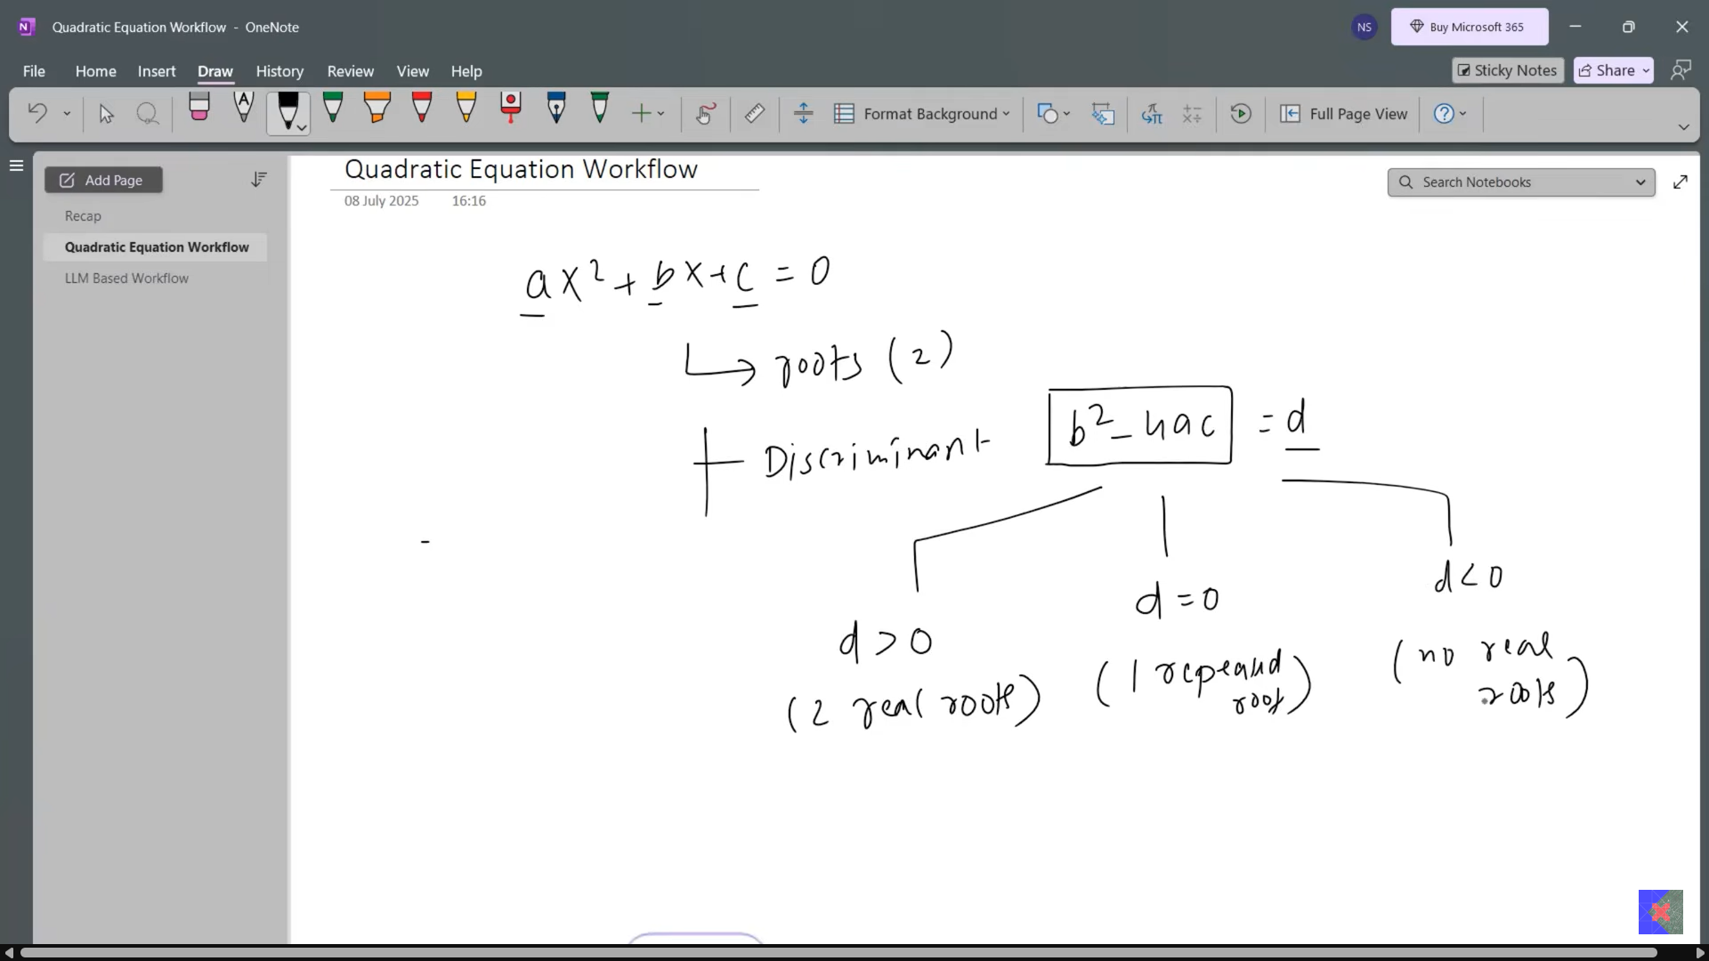

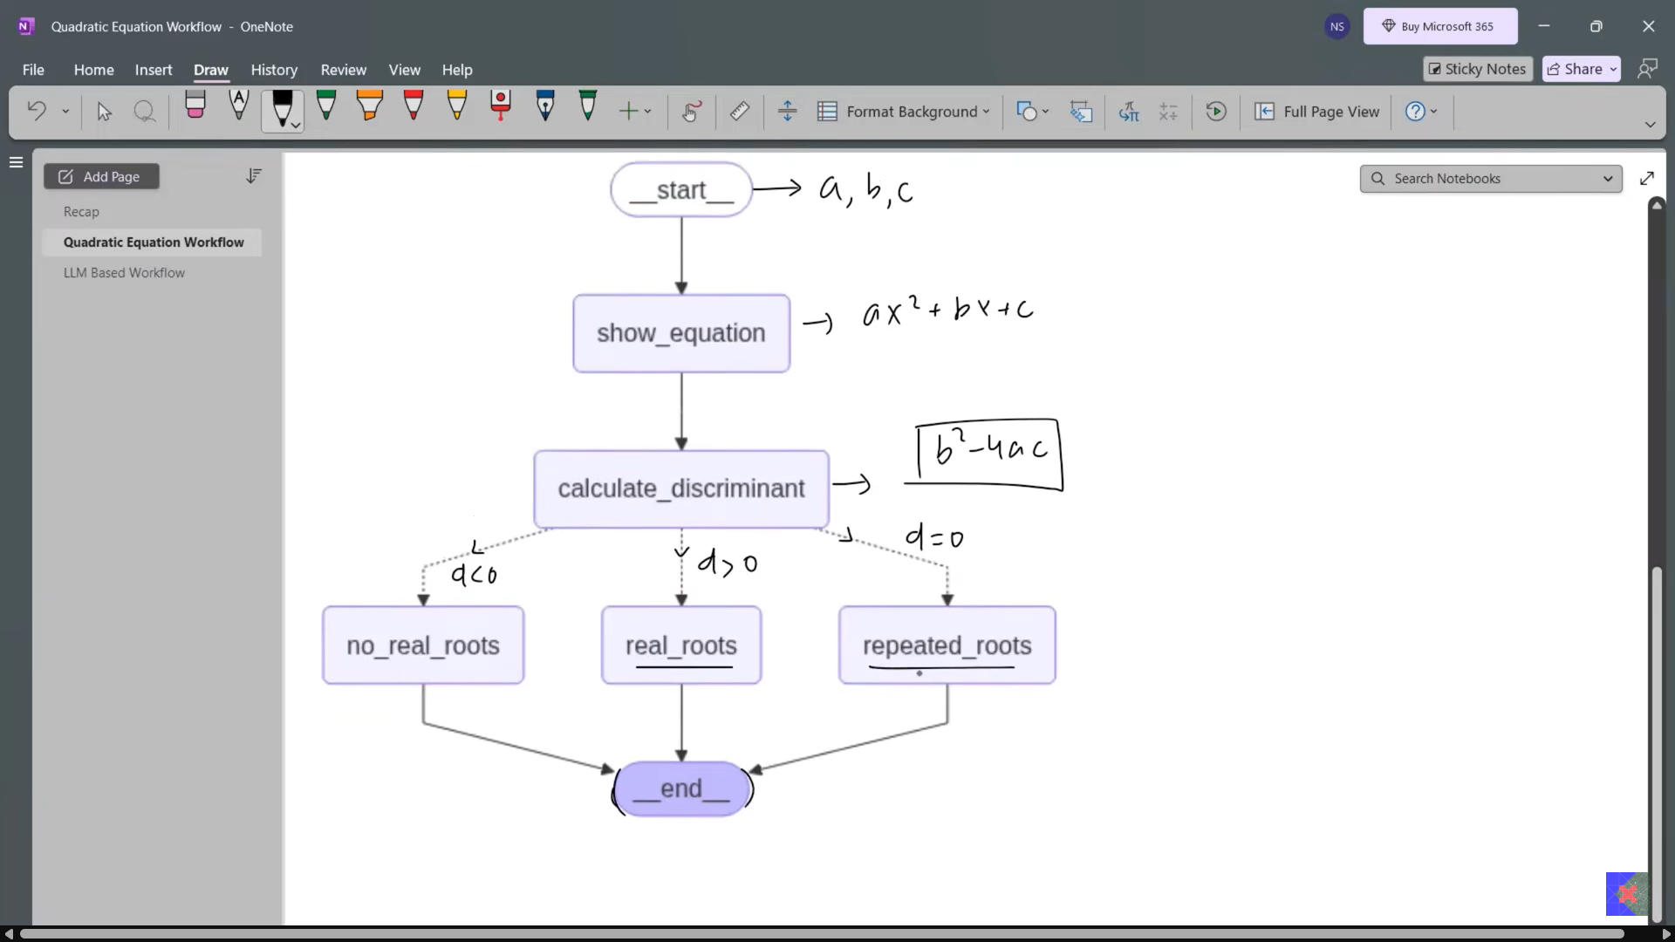

6_quadratic_equation_workflow.ipynb

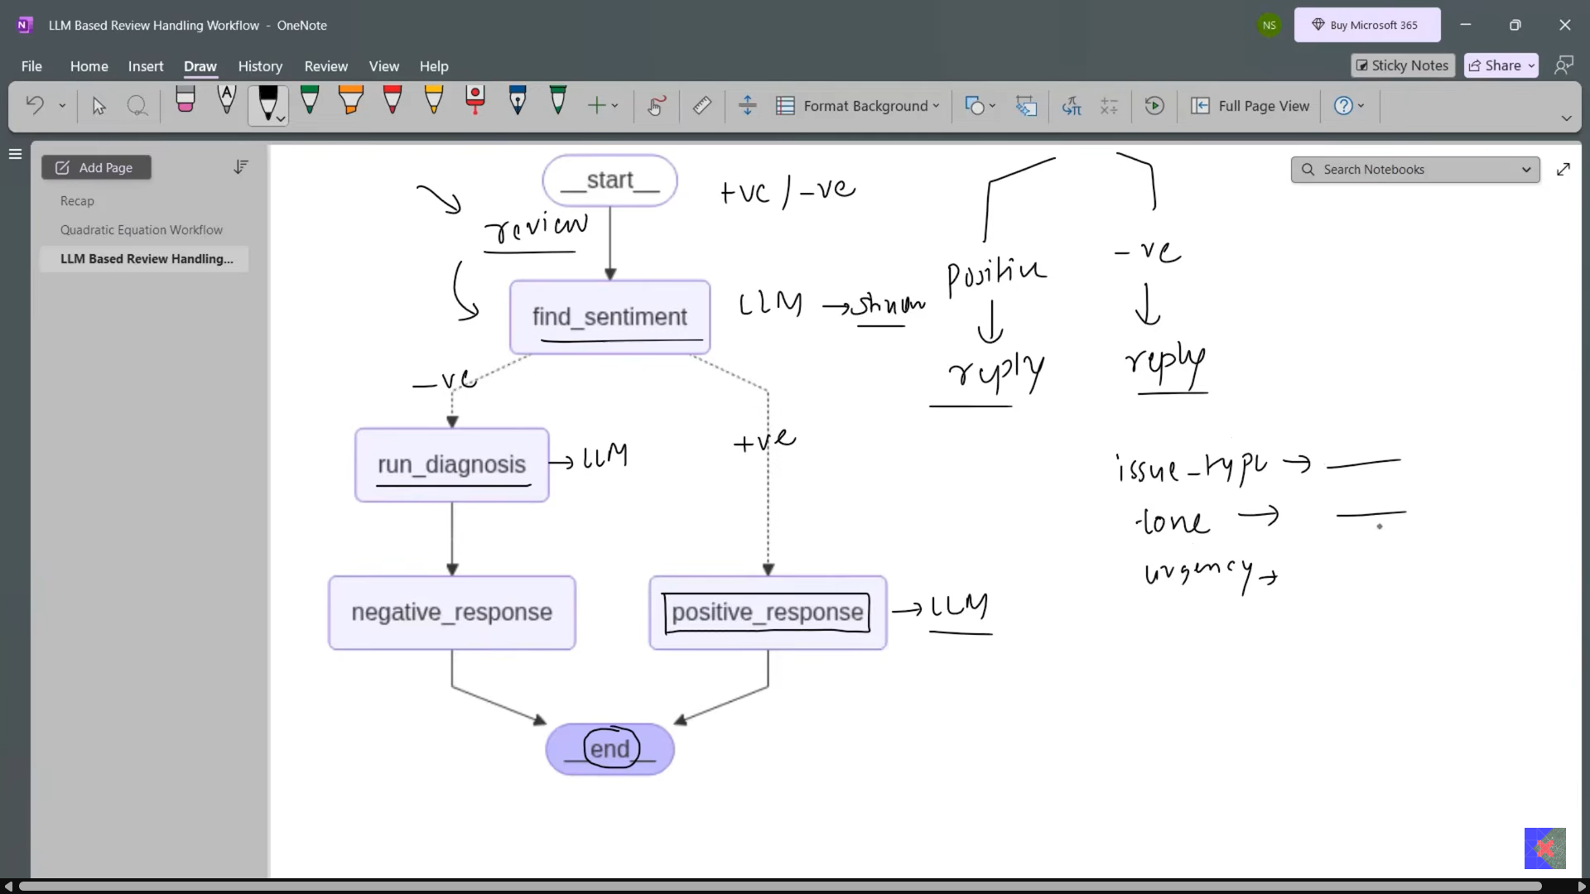

7_review_reply_workflow.ipynb

**Iterative Workflows in LangGraph | Agentic AI using LangGraph | Video 8 | CampusX**

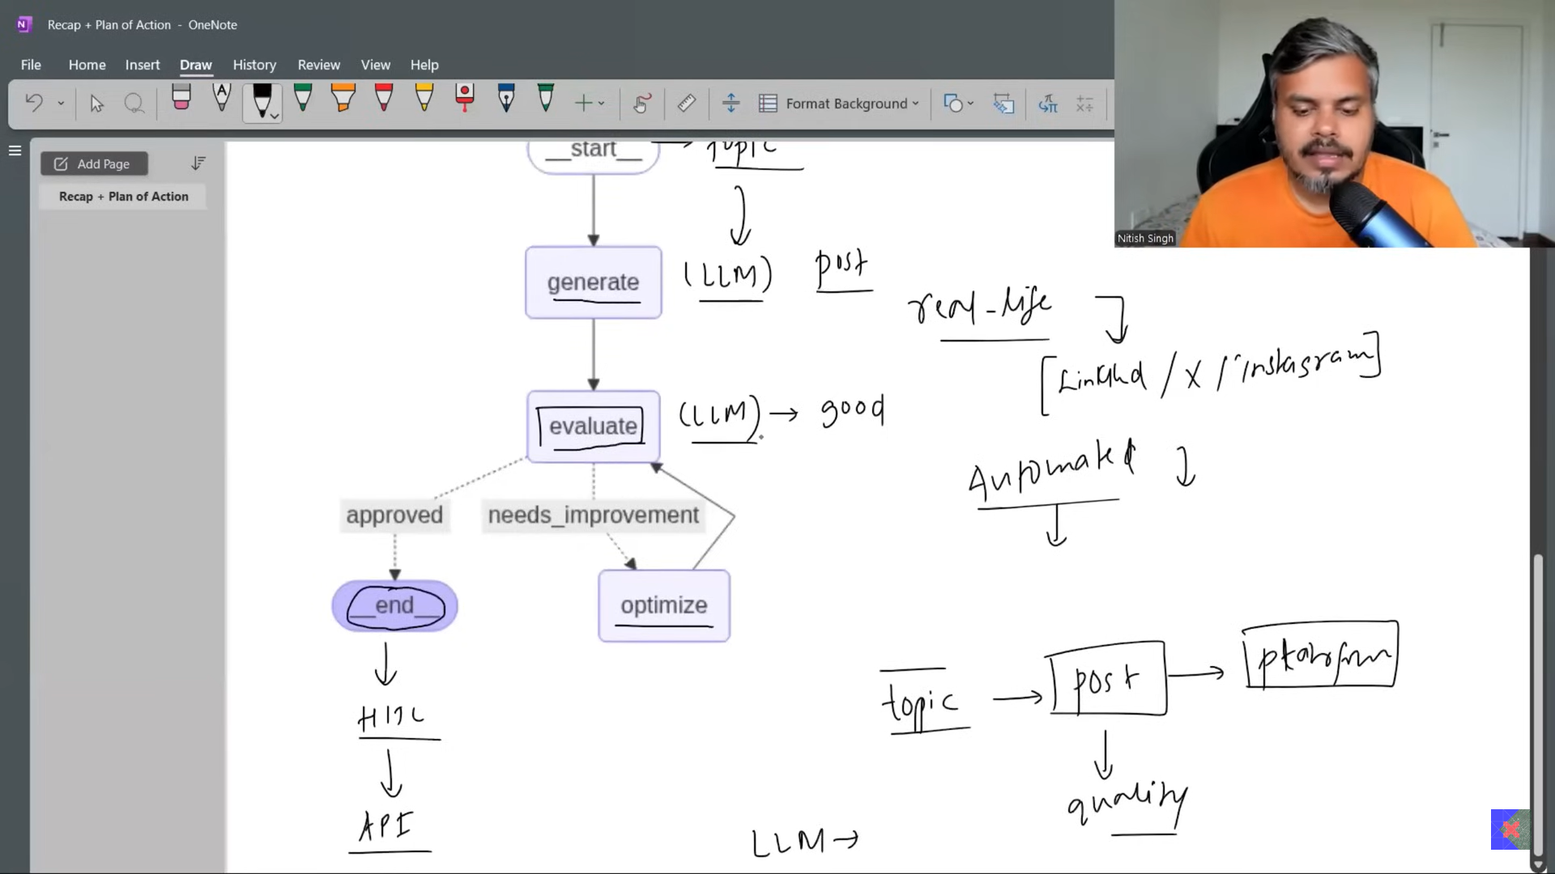

8_X_post_generator.ipynb

**How to build a Chatbot using LangGraph**

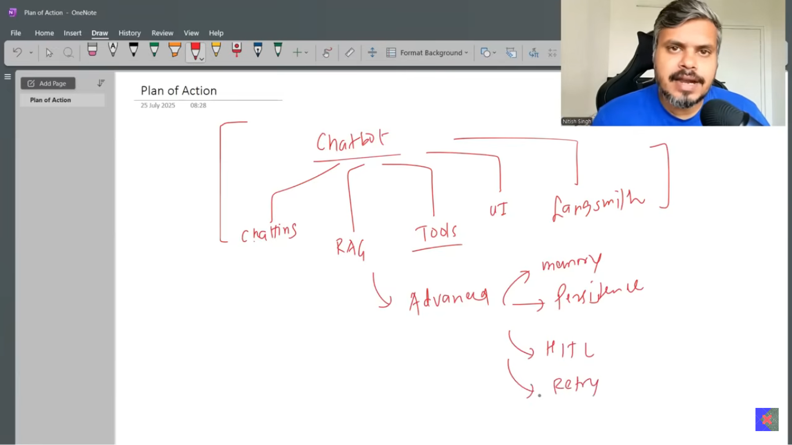

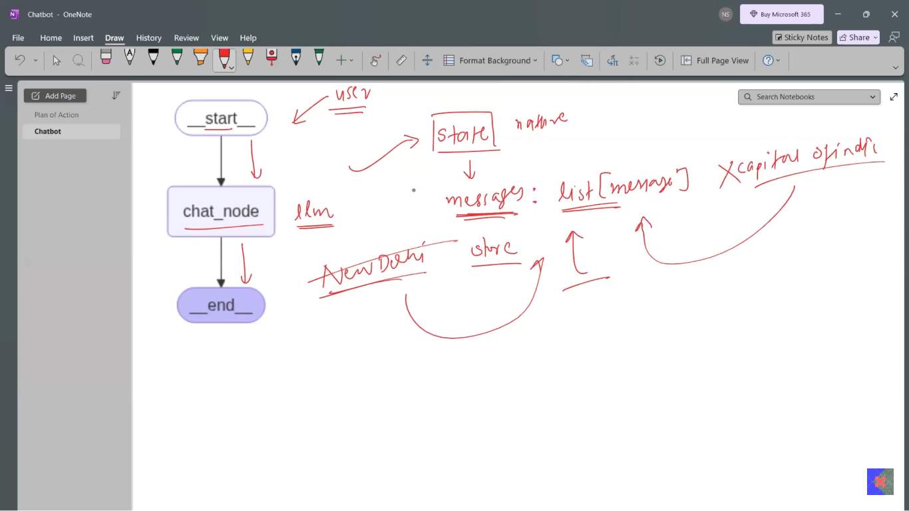

We using memory saver to save chat history in RAM.

Every time chat is appended in state and saved in RAM, during every iteration call state is loaded from RAM.

Note: After program ended chat is removed form RAM, if we want to store chat permanently then we will have to store in db.

Config param is used to distinguish between user.

9_basic_chatbot.ipynb

**Persistence in LangGraph | Time Travel in LangGraph | CampusX**

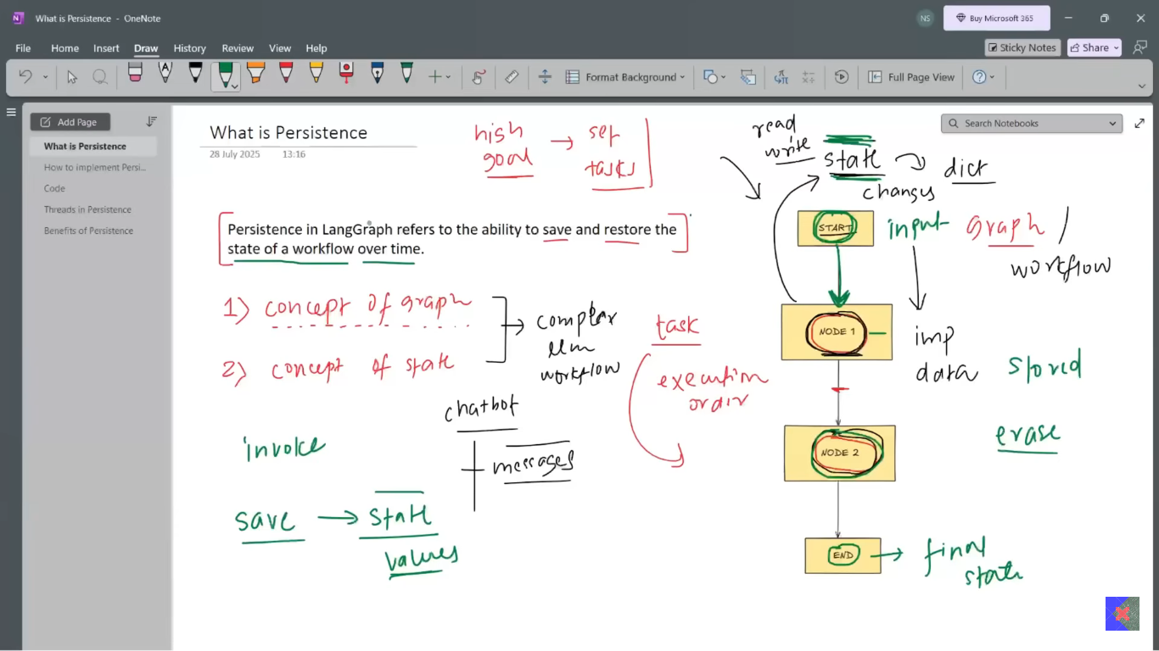

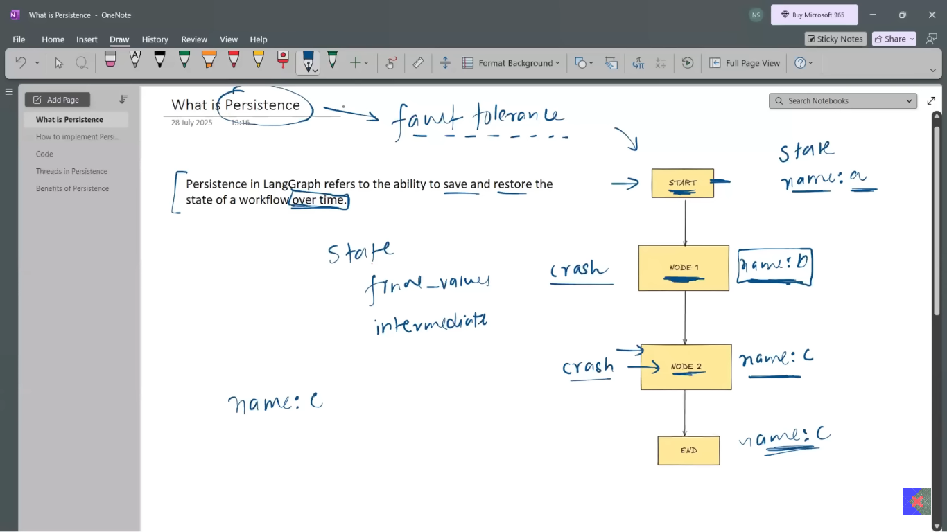

Suppose if system or api down at at node 2 then if we will start then workflow will resume running from node 2 not from start.

This is called fault tolerance handled due to persistence in langgraph.

